What Was Young Earth Like Video Questions
Questions
What were the conditions like on the early Earth?  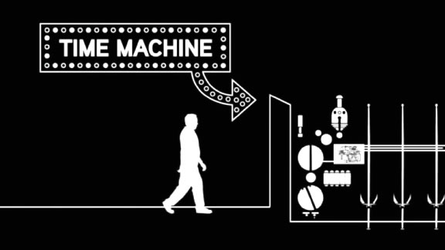 | Part I  - 1:08 What challenges would humans have faced if they lived on the early Earth?  - 2:23 Why was the early Earth so hot?  - 3:57 Why is it important that the inner core of the Earth is metal?  - 4:18 How is the mantle different from the core of the Earth?  - 4:40 How is the crust different from the mantle?  - 4:47 How did the Earth’s atmosphere form?  Part II  - 6:18 What important hypothesis did Alfred Wegener make about the Earth, and what was his evidence?  - 6:33 What was this supercontinent called?  - 7:04 Why were many scientists unwilling to accept Wegener’s hypothesis?  - 7:59 When and how did an explanation for the movement of the Earth’s plates come together?  - 8:57 How does continental crust differ from oceanic crust?  - 9:37 How were the Andes and Himalayas formed?  - 10:59 What is plate tectonics?
Summary (What is the BIG idea presented in the video):

