ASTROPHYSICS
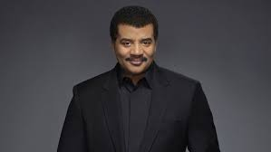
NEIL DEGRASSE TYSON

ASTROPHYSICS 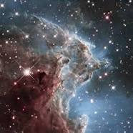 | NEIL DEGRASSE TYSON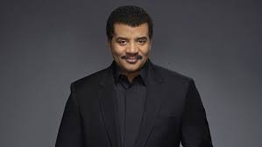
Why Is He Important?
Neil deGrasse Tyson is an American astrophysicist, author, and science communicator. Since 1996, he has been the Frederick P. Rose Director of the Hayden Planetarium at the Rose Center for Earth and Space in New York City. The center is part of the American Museum of Natural History, where Tyson founded the Department of Astrophysics in 1997 and has been a research associate in the department since 2003. He is also the host of the podcast Star Talk, and the television series Cosmos: A Space Odyssey.
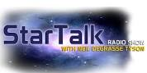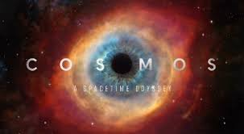
What Do Astrophysicists Study?  They study how the laws of physics can be applied to the natural world and space itself.  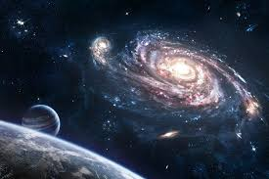 | What Questions Do Astrophysicists Ask?  - How did the universe begin?  - Is the universe evolving?  - Is there more than one dimension to the universe?  - What’s the universe made of?  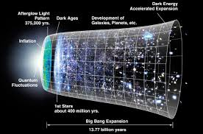
What Resources Do Astrophysicists Use or Need to Conduct Their Research?  - Mathematical Models  - Telescopes  - Experiments  - Observational Data  - Computer Modeling  - The Scientific Method  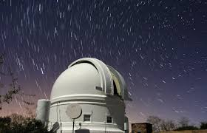 | What Types of Evidence Do Astrophysicists Collect?  - Observations  - Proven Mathematical Equations  - Computer Models  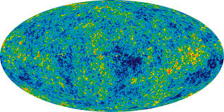
What Other Disciplines Help Astrophysicists?  - Physics  - Chemistry  - Astronomy  - Cosmology  - Mathematics | 