A Big History of Everything Video Questions 1.0
Questions | Notes
What is Big History and how is it different from other history courses?  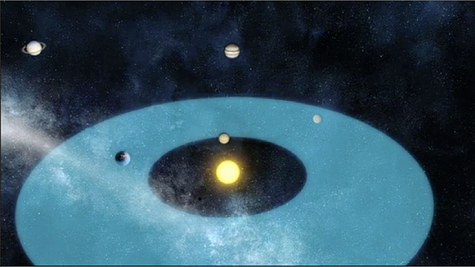 | - 1:38 What is so important about the placement of the Earth in relationship to the Sun?  - 2:50 Why is the Moon so important to our Earth?  - 4:55 What does Jupiter’s location do for the safety of the Earth?  - 6:18 What kind of timeline does Big History follow? In other words, how is Big History’s timeline different from the ones we usually see that are just a straight line?  - 8:05 What is a threshold moment?
Summary (What is the BIG idea presented in the video):

