____________________________________  NAME OF MY ANCIENT ANCESTOR  PICTURE OF MY ANCIENT ANCESTOR | 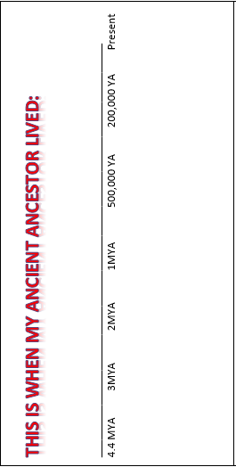 | IMPORTANT CHARACTERISTICS  OF MY ANCIENT ANCESTOR  1.)  Picture:  2.)  Picture:  3.)  Picture

DIFFERENCES FROM  PREVIOUS ANCIENT ANCESTORS | THIS IS ANCIENT WAS LOCATED: