Archaeological analysis rewrites the cautionary tale of Easter Island
Michael Irving July 11, 2017
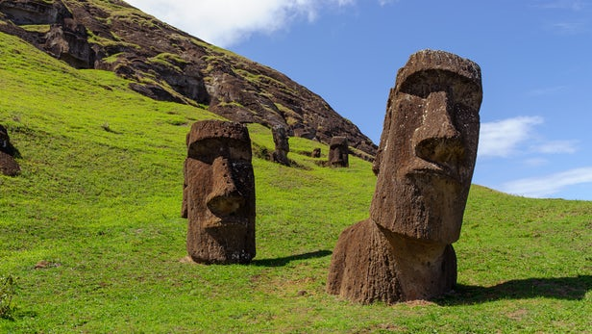

Easter Island (or Rapa Nui) is known for two things: giant stone heads and the cautionary tale of an isolated civilization that destroyed itself through reckless misuse of environmental resources. But new analysis of archaeological remains might rewrite the narrative, painting the Rapa Nui people in a more positive light.
When Europeans first landed on Easter Island in the 18th century, they found a barren landscape. The story goes that to raise the huge stone heads, called moai, the Rapa Nui people felled most of the island's trees to use as rollers, burning the rest for fuel and warmth. The negative effects of a treeless island cascaded down, destroying their previous prosperity and leaving the tribes fighting over resources.
"The traditional story is that over time the people of Rapa Nui used up their resources and started to run out of food," says Carl Lipo, co-author of the study. "One of the resources that they supposedly used up was trees that were growing on the island. Those trees provided canoes and, as a result of the lack of canoes, they could no longer fish. So they started to rely more and more on land food. As they relied on land food, productivity went down because of soil erosion, which led to crop failures … painting the picture of this sort of catastrophe. That's the traditional narrative."
To get a better understanding of what the people of Easter Island were eating and how, a team from Binghamton University analyzed human, animal and plant remains dating as far back as 1400 CE. Analyzing the carbon and nitrogen isotopes of the collagen in bones can reveal the diet of ancient people, and these were compared with isotope analyses of the ancient and modern plant and marine samples to get an idea of where their food was coming from.
The results showed that about half of the proteins the Rapa Nui people were consuming came from marine sources, which means they were fishing more consistently for a longer period than they were given credit for. At the same time, the food they were cultivating on land was more productive than previously thought, with the environmental analyses showing an understanding of how to improve poor soil fertility.
"We found that there's a fairly significant marine diet, over time, throughout history and that people were eating marine resources, and it wasn't as though they only had food from terrestrial resources," says Lipo. "We also learned that what they did get from terrestrial resources came from very modified soils, that they were enriching the soils in order to grow the crops. That supports the argument we've made in our previous work, that these people came up with an ingenious strategy in enriching the soils by adding bedrock to the surface and inside the soil to create, essentially, fertilizer to support their populations, and that forest loss really isn't a catastrophe as previously described."
Although the story of the Rapa Nui's self-destruction serves as a good fable to teach environmental awareness and responsibility, the Binghamton team concludes that it's not that simple. The history of Easter Island is more nuanced, and the ancient people shouldn't be written off as reckless and careless.
The research was published in the American Journal of Physical Anthropology.
Source: Binghamton University via Newswise

