Aspects of Civilizations Vocabulary
Questions | Notes
What are the aspects of a civilization?  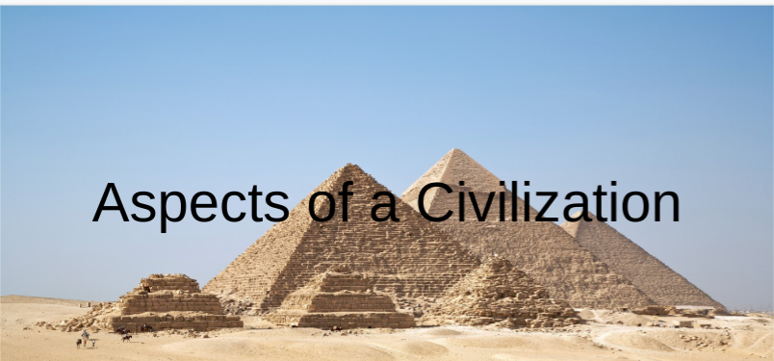 | Agriculture & Food Surplus:  - Definition:  - Example:  - Picture:  Religion:  - Definition:  - Example:  - Picture:  Government:  - Definition:  - Example:  - Picture:  Specialization of Labor:  - Definition:  - Example:  - Picture:  Social Hierarchy:  - Definition:  - Example:  - Picture:  Economy & Trade:  - Definition:  - Example:  - Picture:  System of Writing:  - Definition:  - Example:  - Picture:  Expansion of Territory:  - Definition:  - Example:  - Picture:  Monumental Architecture:  - Definition:  - Example:  - Picture:  Increased Gender Inequality (Patriarchy):  - Definition:  - Example:  - Picture:  Achievements & Inventions:  - Definition:  - Example:  - Picture:
Summary (What is the BIG idea presented in the slide show):

