
Then Earth’s oceans have a predictable rise and fall (Tides).

Because there have been millions of supernovae throughout the universe,

Then there have been the creation of many exoplanets that orbit other stars.
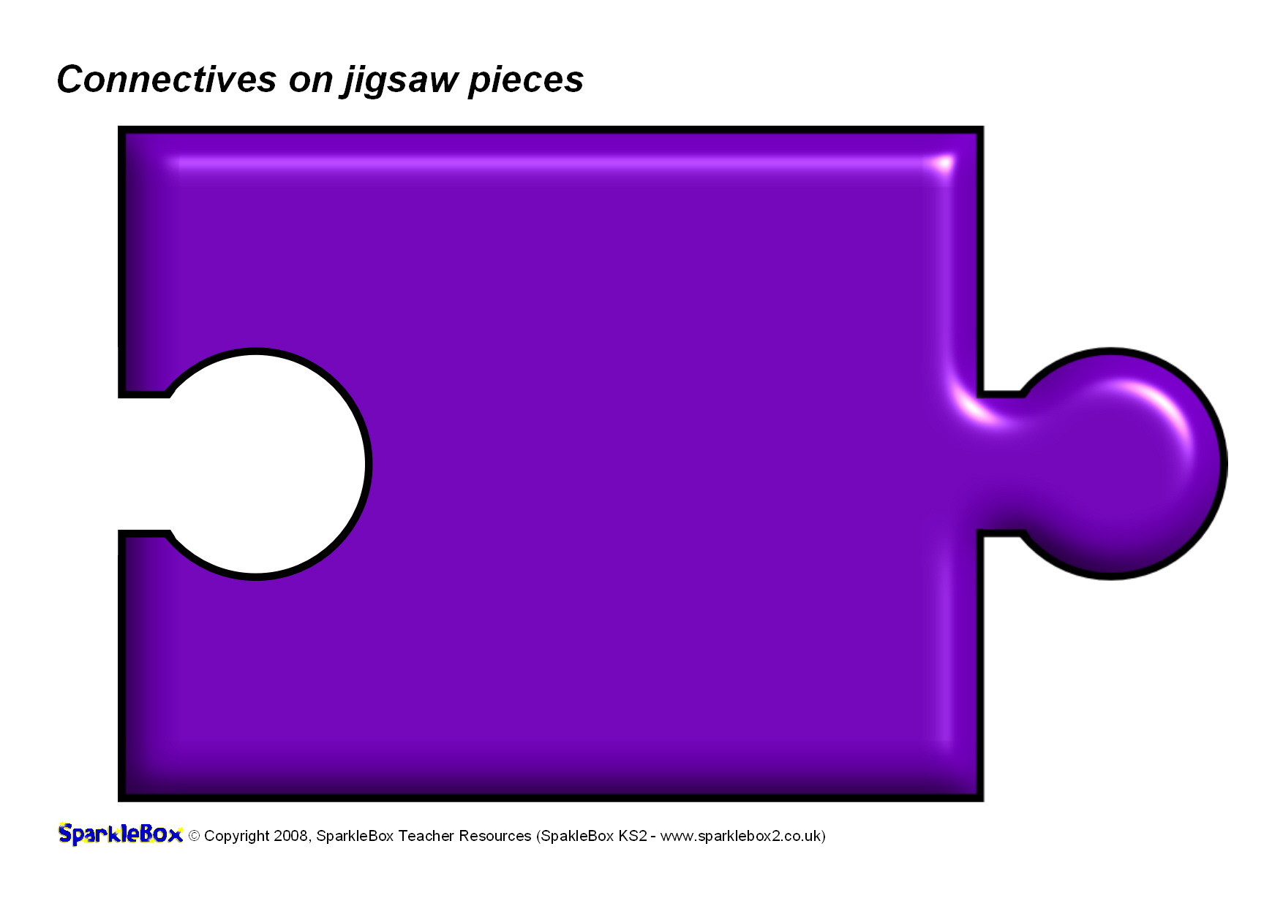





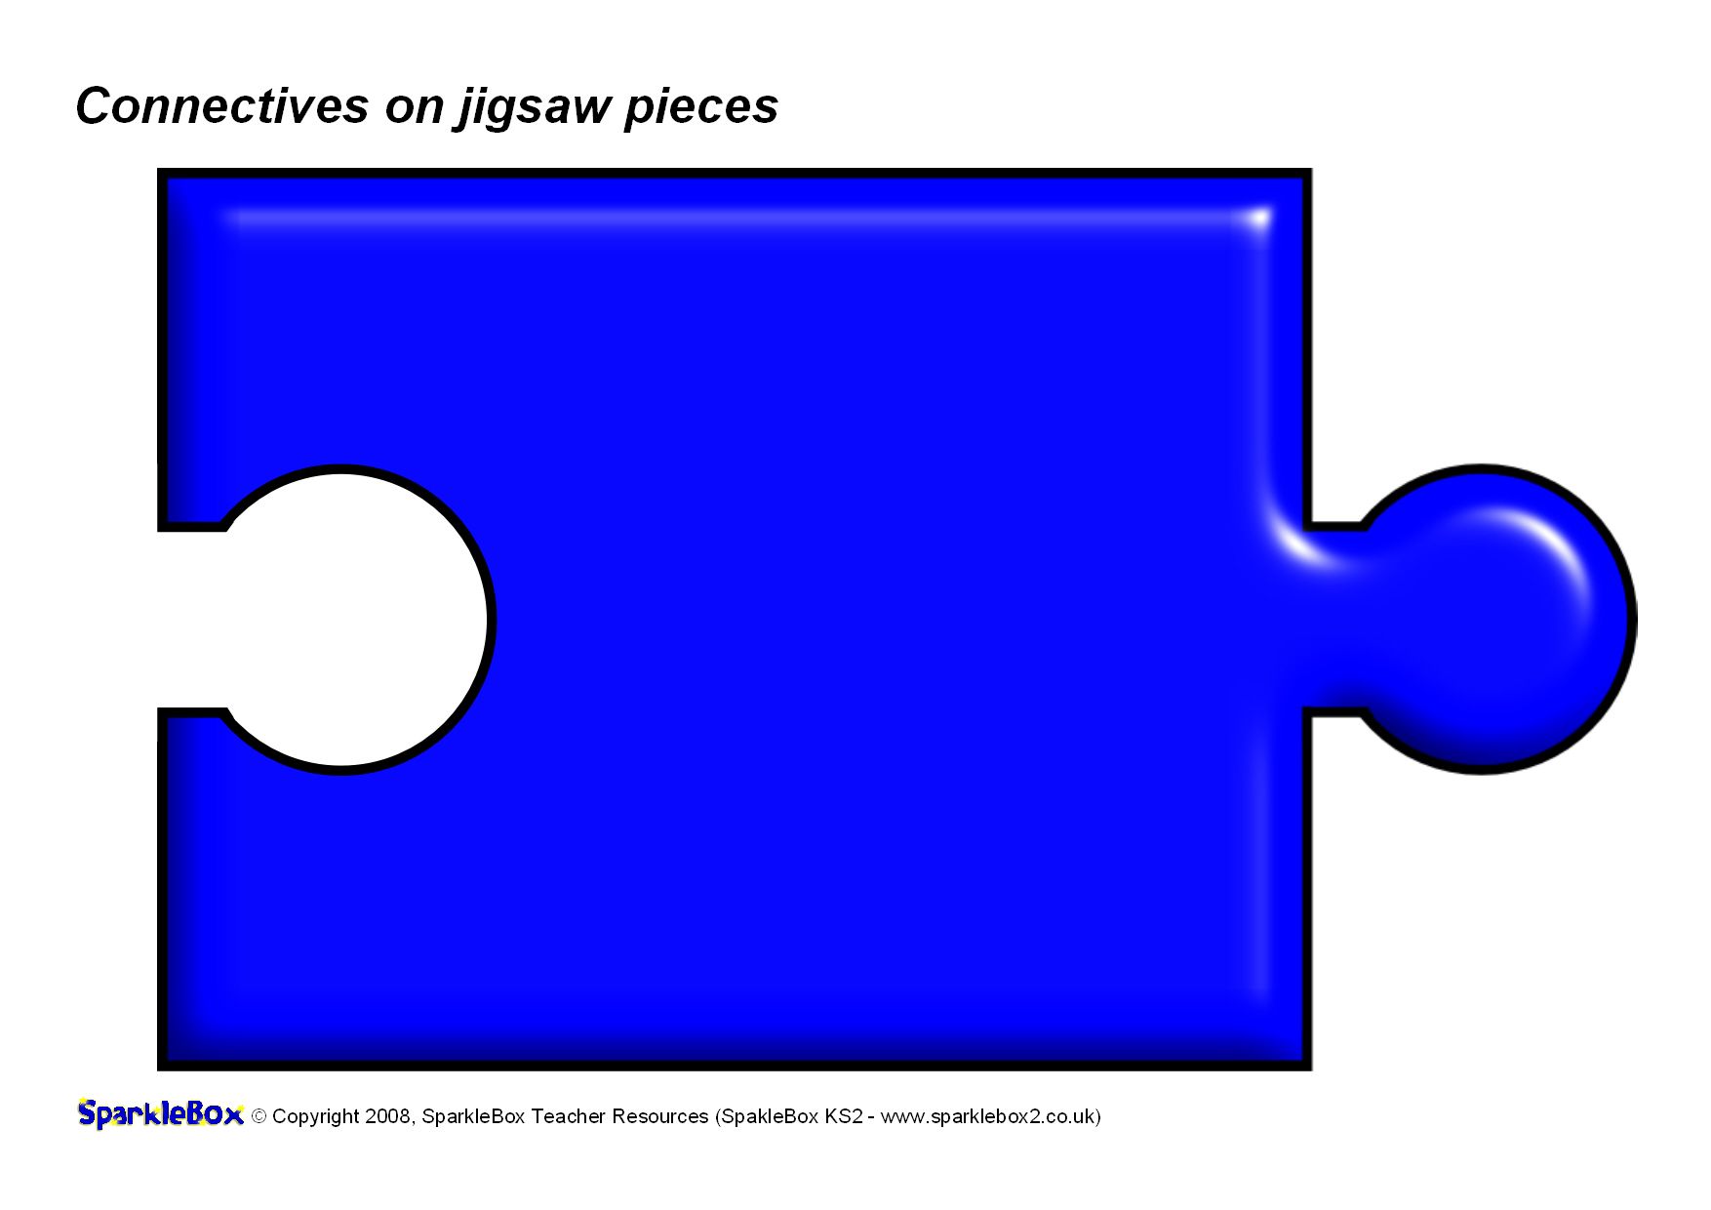
[Name]
[Name]
[Name]
[Name]
[Name]
[Name]
[Name]
[Name]

