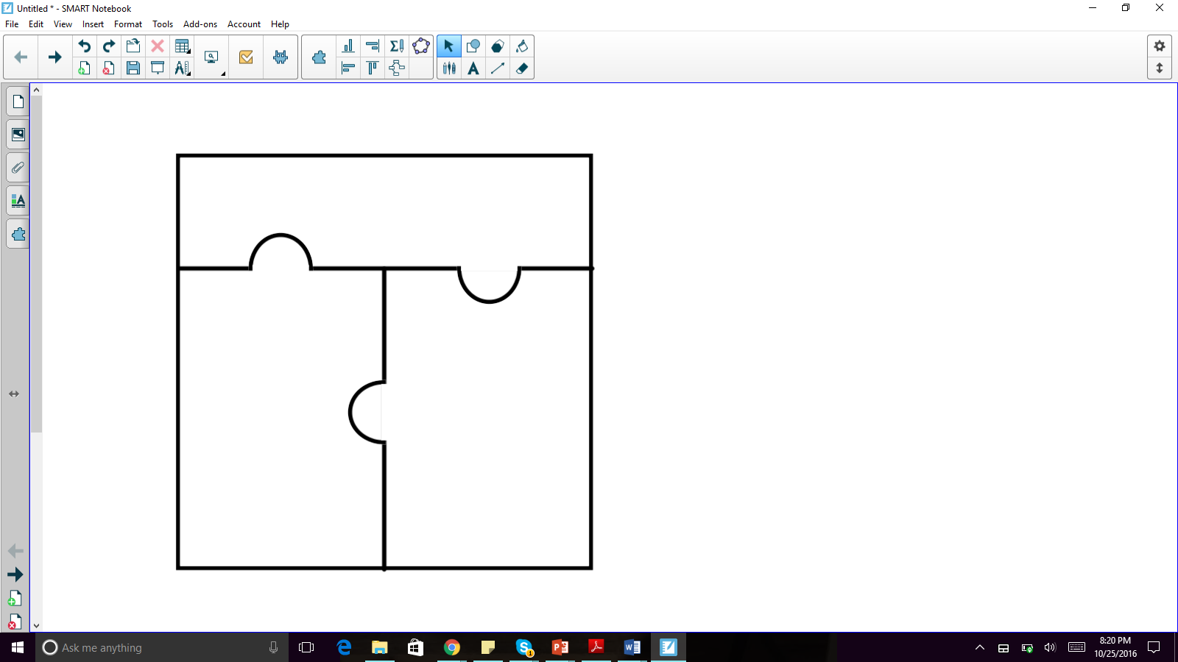

Asteroid

Accretion

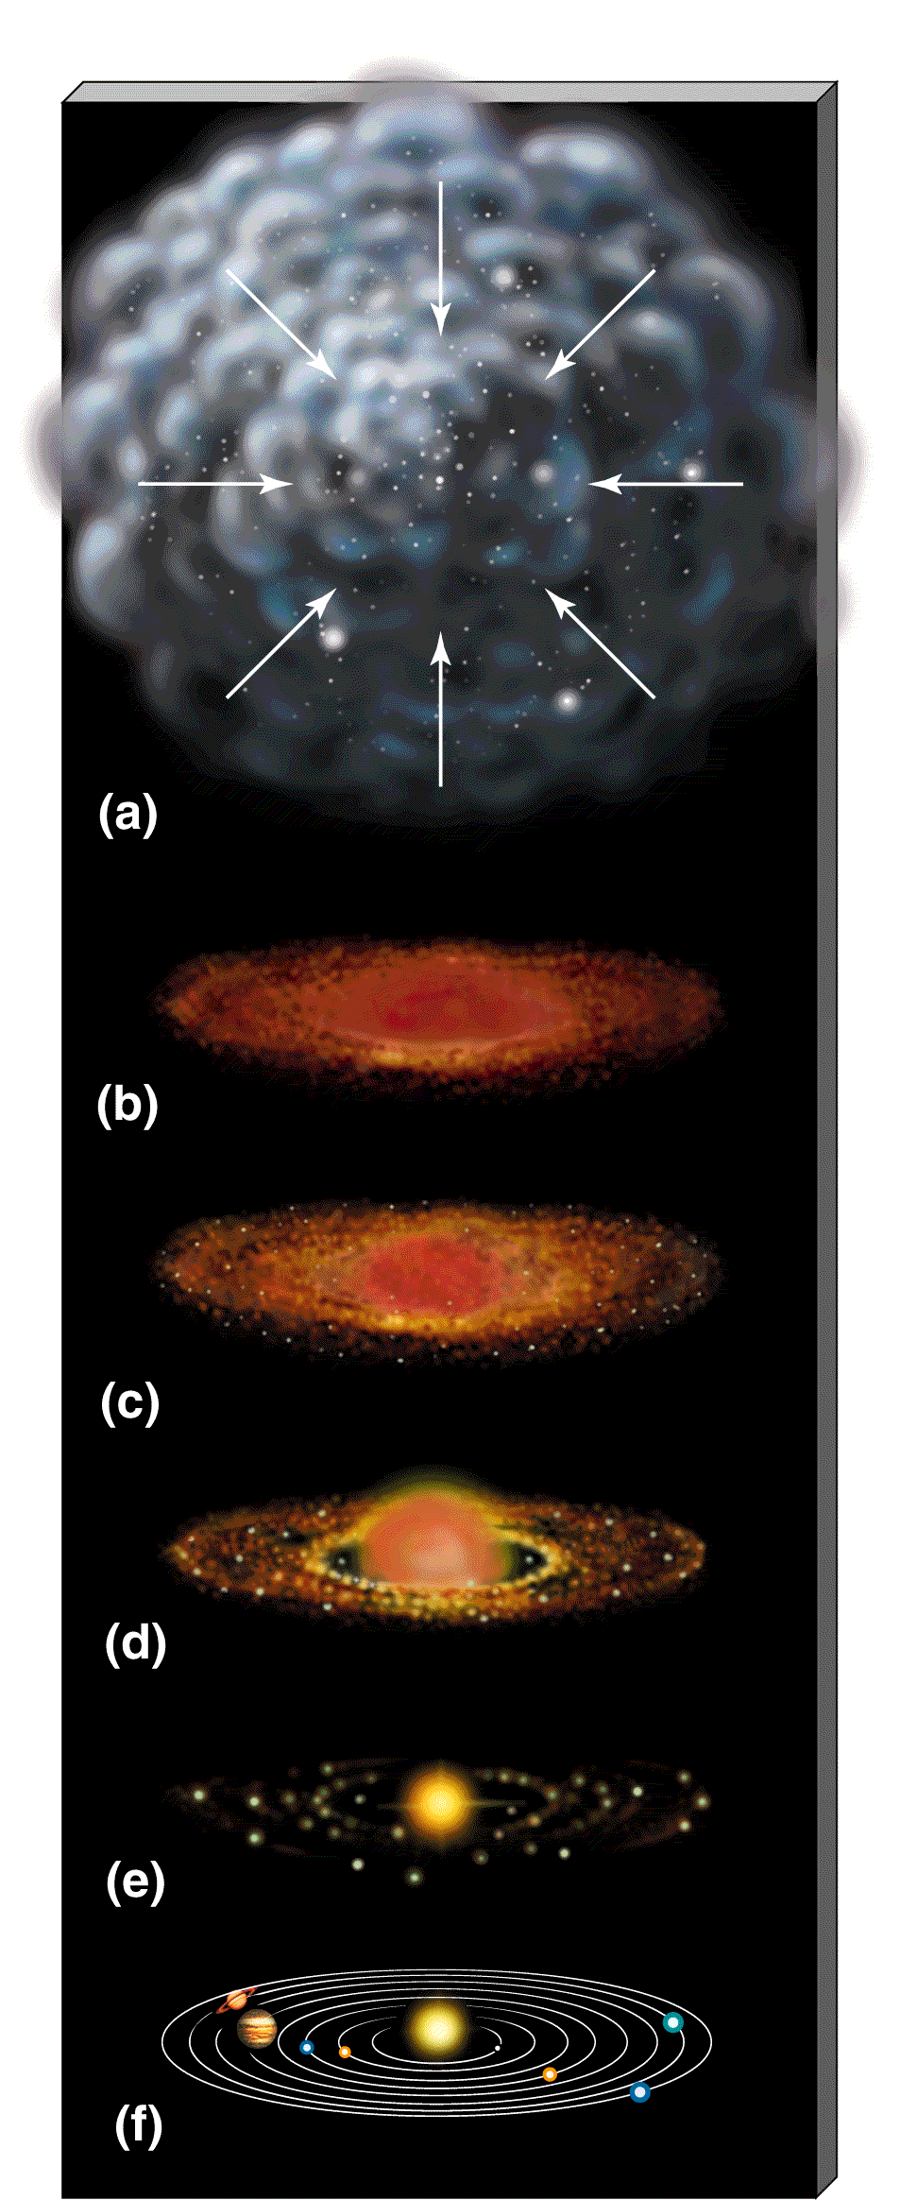

Small rocky, icy, and metallic celestial body left over from the formation of the Solar System.

The formation of planets as they orbit around the stars.

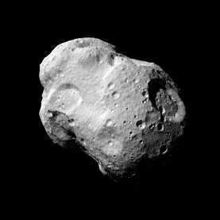



Core (of the Earth)

Circadian Rhythm

Master clock controlling the body’s systems based on the sun’s 24-hour cycle.

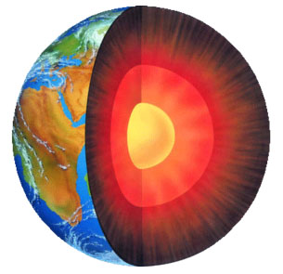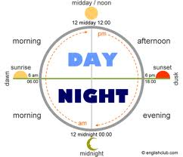

The dense center of the Earth made mostly of iron and some nickel.



Exoplanet

Crust (of the Earth)



The solid outer layer of the Earth, consisting of moving plates.

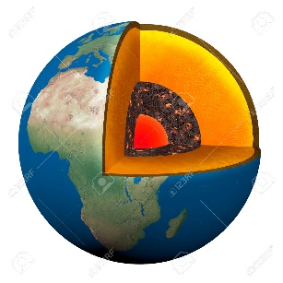

A planet outside of our solar system.

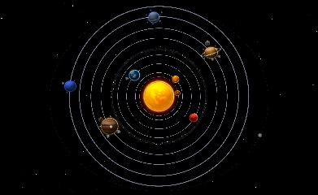

(solar system)



Orbit

Mantle

The layer of the Earth that is between the core and the crust and can be flowing, causing the plates to move.



The path of a body through space, often dictated by gravitational pull.

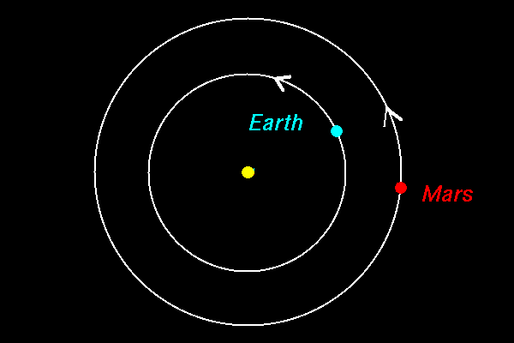



Planetesimal

Planet

An object smaller than a planet that forms during accretion that may form into a planet.

A spherical ball of rock, gas, or both in orbit around a star.

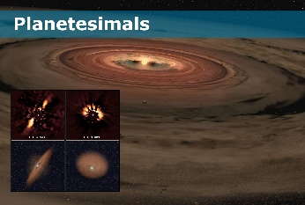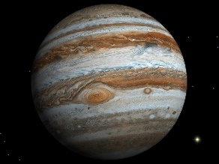

Archaean Eon

Protoplanetary disk

The second eon in Earth’s history (3.8-2.5 MYA) when the first organisms appeared.

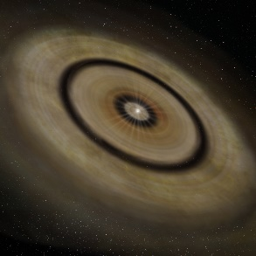

Gas and dust around a star that forms planets.

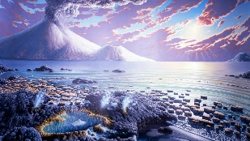

(Earth 3.8-2.5 million years ago)



Greenhouse Effect

Atmosphere

The process by which the gases of the atmosphere trap heat near Earth’s surface.

A mixture of gases around a planet.

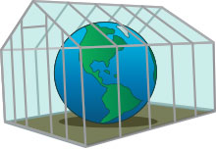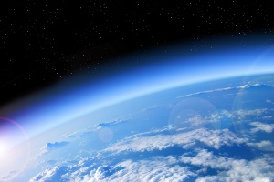

Ozone

Hadean Eon

The first eon in Earth’s history (4.5-2.8 billion years ago) when Earth was forming, but not suited for life.

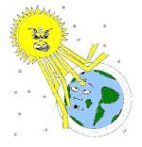

The layer of atmosphere that shields the Earth from the sun’s radiation

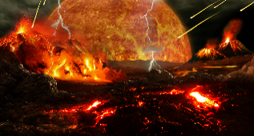

(Earth 4.5-2.8 billion years ago)



The idea that the continents are continually moving and were once connected together.

The vast supercontinent that existed 200 million years ago.

The scientific study of the Earth’s past.

The idea that the Earth’s crust rests on plates and is continually moving.

Continental drift

Pangaea

Geology

Plate tectonics

