Investigating the Consequences of the Columbian Exchange Reading Questions
Questions | Notes
What impact did the Columbian Exchange have on the world?  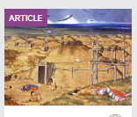 | - When and what was the Columbian Exchange?  - What are some of the things that moved east during the Columbian Exchange?  - What are some of the things that moved west during the Columbian Exchange?  - What were some of the intentional and what were some of the unintentional exchanges from this time?  - What is “the great dying”?  - According to the table in the reading, what were the main population trends in each of the regions listed from 1400 to 1700?  - How did the author come to her conclusions about the population changes during the Columbian Exchange?  - What does the author list as the consequences of the Columbian Exchange?
Summary (What is the BIG idea presented in the reading):

