Essential Question: What happened to the people of Easter Island & why did they have statues?
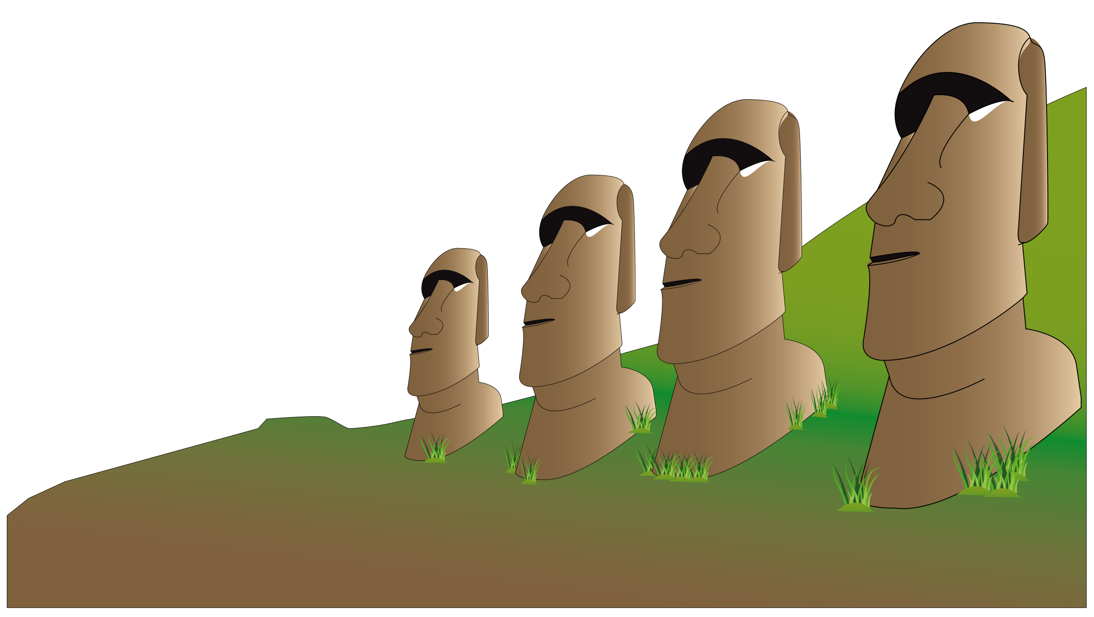

Directions:
- As you read, answer the question in the first column (causes).
- Identify evidence to support your answer in the second column (answer & evidence).
- The source is already filled out for you
- Identify the type of expert in the fourth column (expert)

Cause | Answer & Evidence | Source | Expert
Q: Where did the original people come from and why did they have statues? | Explain. | #1: From where did they sail? | Who is the expert?
Q: Why did they have statues? | Explain. | #2: The statue builders | Who is the expert?
Q: What happened to the people of Easter Island? | Explain. | #3: Scarce Violent Times | Who is the expert?
Q: What happened to Easter Island? | Explain. | #4: A parable for the world? | Who is the expert?
Q: Why were some people still alive? | Explain. | #5: Back from the brink | Who is the expert?
Q: What happened to the people of Easter Island? | Explain. | #6: Final Assault | Who is the expert?

CER

In your opinion, which of the causes listed above had the biggest impact on the collapse of Easter Island and why?
Claim:

Evidence:

Reasoning:

Scroll Down to see Grading Rubric
Work Habit | Meeting | Approaching | Beginning
I completed my work. | I attempted all parts of the assignment. | I attempted at least half of the assignment. | I started the assignment.

Evidence | Exceeding | Meeting | Approaching | Beginning
Identify | Student can identify the expert and new evidence found from both sources. | Student can identify the expert and new evidence found from at least 1 of the sources. | Student can identify the expert or new evidence found from the source(s). | Student attempts to identify the expert and evidence found from the source(s).

