Essential Question: What happened to the people of Easter Island & why did they have statues?
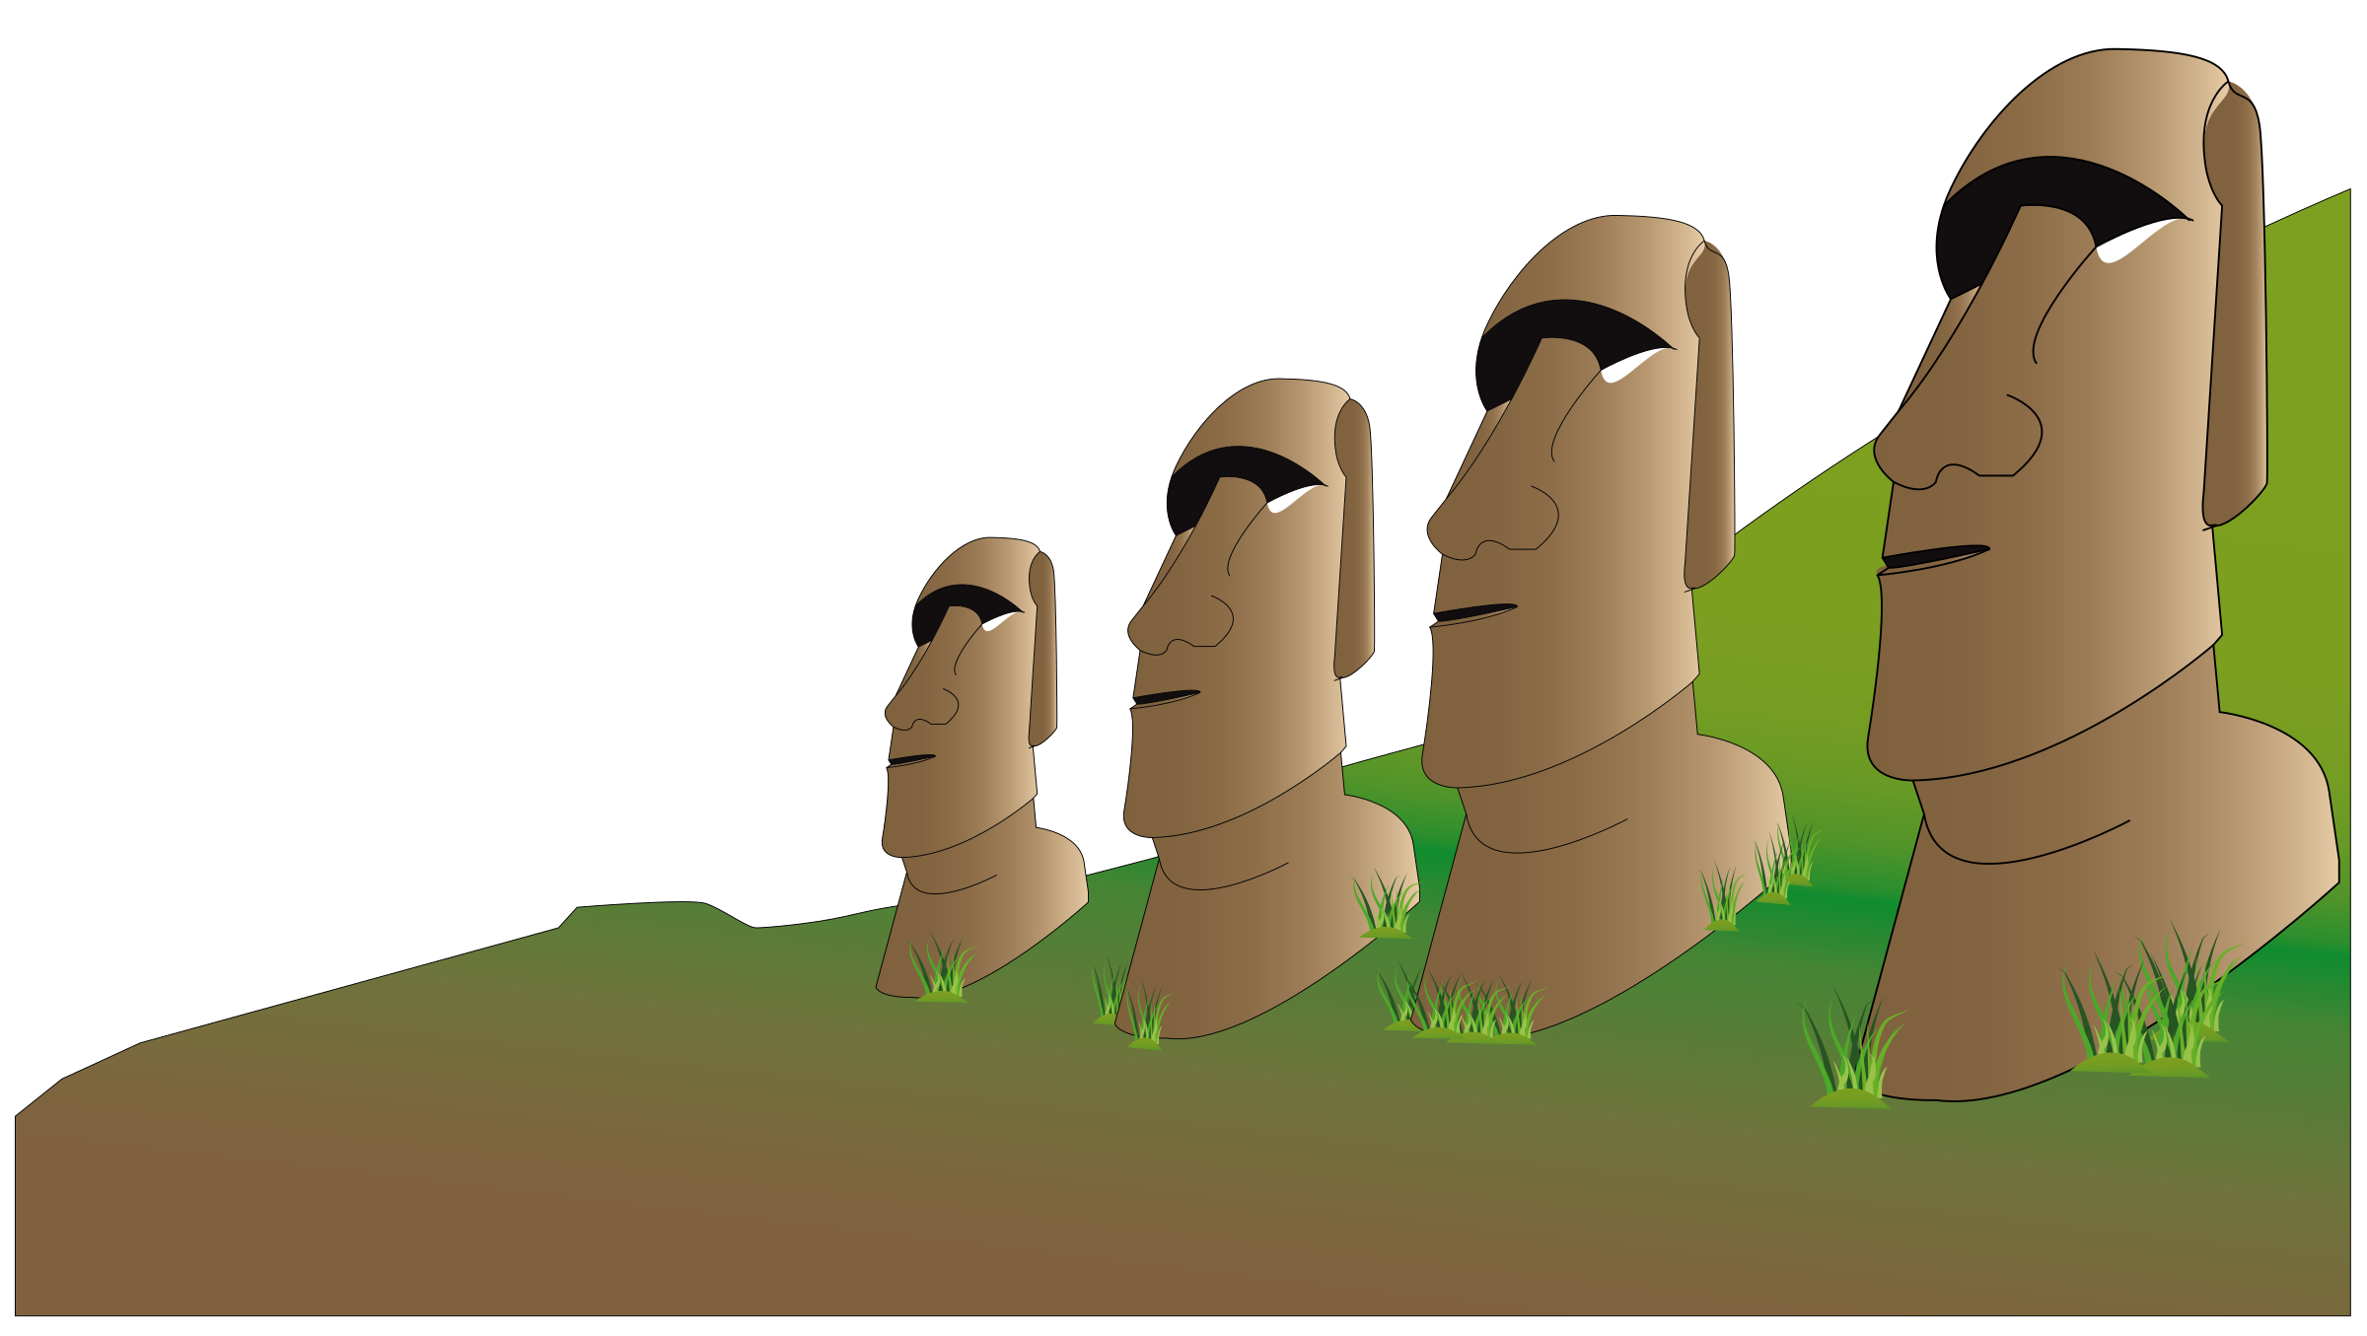

Day 2:
As you examine and analyze some “new” documents for “History as Mystery: What Caused the Collapse of Easter Island?” complete the graphic organizer below.

Original Cause(s) | New Evidence | Source | Expert
Civil War, Starvation, and Cannibalism | Part 1: The Ecocide Narrative Does Not Stand Up  Part 2: But Is This Really the Case? | #1 The Truth about Easter Island
Deforestation- they ran out of trees and couldn’t make canoes for fishing | Part 3: What Really Happened to the Trees?  Part 4: Blame Slavers-Not Lumberjacks | #2 The Truth about Easter Island
The Rapu Nui were to blame for deforestation. |  | #3 What happened to Easter Island Video
The Moai statues walked from one part of the island to another. |  | #4 Walking with Giants Video
The Moai statues walked from one part of the island to another. |  | #5 Moving the Moai

CER
Should we look at Easter Island as a cautionary tale of human impacts on the environment, or the cautionary tale of humankind’s impacts on other humans, and why? Be sure to support your answer with specific evidence from the documents.
In other words, what REALLY led to the collapse of Easter Island?
Be sure to support your answer with specific evidence from the documents.
Claim: I think the people of Easter Island died because of...

Evidence: In document #, it shows that…..

Reasoning: My evidence shows that..
Why did you choose this evidence?

Scroll Down for Grading Rubric

Work Habit | Meeting | Approaching | Beginning
I completed my work. | I attempted all parts of the assignment. | I attempted at least half of the assignment. | I started the assignment.

Evidence | Exceeding | Meeting | Approaching | Beginning
Identify | Student can identify the expert and new evidence found from both sources. | Student can identify the expert and new evidence found from at least 1 of the sources. | Student can identify the expert or new evidence found from the source(s). | Student attempts to identify the expert and evidence found from the source(s).

