The Big Bang: Everything You Ever Wanted to Know
As you watch the each of the videos, answer the following questions:
A Big History of Everything
Questions | Notes
What is the first Threshold of Big History, and why is it important?  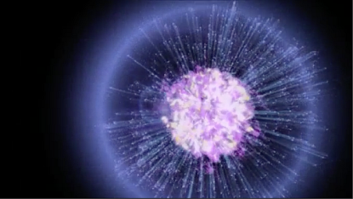 | - 1.) 0:51 What is Big History’s first threshold, and what did it come from?  - 2.) 2:19 What fundamental force appears after the Big Bang that is part of the forces that govern all existence forever?  - 3.) 2:41 What could have gone wrong in the first few seconds of the Universe?  - 4.) 2:56 Why is the Big Bang the first of eight thresholds?
Summary (What is the BIG idea presented in the video):

Threshold 1: The Big Bang
Questions | Notes
What is the Big Bang, and why was it important?  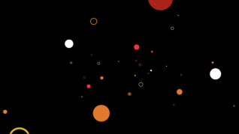 | - 1.) 0:15 When did the Big Bang happen?  - 2.) 0:25 Why don’t we know the ingredients and Goldilocks conditions for the Big Bang?  - 3.) 0:50 What raw materials did the Big Bang Provide?  - 4.) 1:15 What forms did energy take after the Big Bang?  5.) 1:20 What forms did matter take?  - 6.) 1:30 Why does this matter (no pun intended)?  7.) 1:40 What new complexity was created by the Big Bang?
Summary (What is the BIG idea presented in the video):

Questions About the Big Bang
Questions | Notes
What questions are still left unanswered about the Big Bang? | - 1.) 1:15 What evidence is there that the universe is expanding?  2.) 2:15 What are some of the questions we still can’t answer about the Big Bang?
Summary (What is the BIG idea presented in the video):

Electromagnetism
Questions | Notes
What is electromagnetism, and how have humans used it?  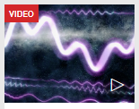 | - 1.) 0:35 How far can a human voice travel before it runs out of energy?  2.) 1:56 How can we extend our voices?
Summary (What is the BIG idea presented in the video):

Jacqueline Howard Presents: Looking into the Past
Questions | Notes
What have humans learned about the universe?  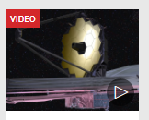 | - 1.) 0:48 How quickly does light travel?  2.) 4:10 What evidence did Hubble have for the expansion of the universe?  3.) 5:40 What is the significance of the Hubble eXtreme Deep Field?  4.) 6:20 What is the goal of the James Webb space telescope?
Summary (What is the BIG idea presented in the video):

