Crash Course: Industrial Revolution
Questions | Notes
What caused the Industrial Revolution, and what impact did it have on the world?  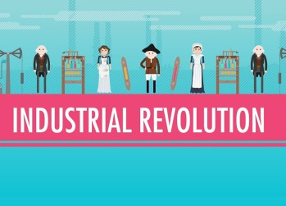 | - 0:18 How is the Industrial Revolution different from other revolutions, like the American, French, Latin American, and Haitian revolutions?  - 1:48 What kind of work did most people do before the Industrial Revolution?  - 2:15 What is the definition of the Industrial Revolution?  - 2:30 When and where did the Industrial Revolution begin?  - 4:10 What is Eurocentrism and why have explanations for the Industrial Revolution sometimes been called Eurocentric?  - 5:50 Why have some historians criticized the Eurocentric focus on cultural superiority?  - 7:05 If cultural superiority can’t explain why the Industrial Revolution began in England, what other factors might explain it?  - 8:15 Why were wages so important?
Summary (What is the BIG idea presented in the video):

