Crash Course: The Anthropocene Questions
Questions | Notes
What is the Anthropocene, and how has it impacted the world?  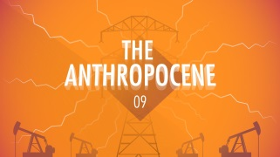 | - 2:31 What does it mean to say that collective learning has grown exponentially?  - 3:10 What were some of the reasons so many people died in the twentieth century?  - 5:10 How is the distribution of wealth today different from the distribution of wealth during the agrarian era? How is being in the top 10 to 20 percent different than it used to be?  - 9:17 What are some of the positive things about the Anthropocene, and what are some of the negatives?  - 10:21 What are some of the possible scenarios for the future?  - 10:49 What are some of the dangers of the twenty-first century?
Summary (What is the BIG idea presented in the video):

