Crash Course: The Big Bang Video Questions
As you watch the each of the video, answer the following questions:
Crash Course: The Big Bang
Questions | Notes
What was the Big Bang, and why is it so important to our story of Big History?  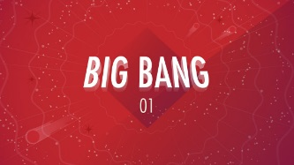 | - 1.) 1:11 Why is the Big Bang a good start date for history?  - 2.) 3:05 What do different scales give you?  - 3.) 5:03 How old is the Universe?  - 4.) 6:04 How do we know that the Big Bang is the beginning?  - 5.) 8:35 What are the two simplest elements that were formed after the Big Bang?  - 6.) 9:43 What is cosmic background radiation (CBR)?  - 7.) 11:14 What is redshift?
Summary (What is the BIG idea presented in the video):

