Threshold 4 Video Questions
Questions | Notes
What is the Big History’s 4th Threshold, and what did it produce?  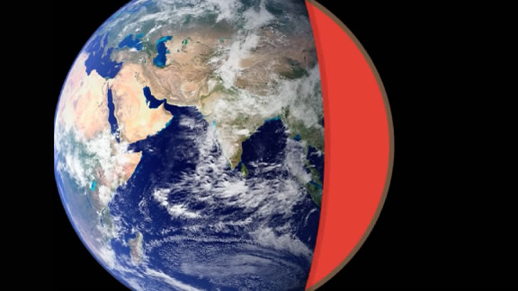 | - What percentage of the elements make up the matter in the universe?  - Why are the 2% of other elements so important?  - What is Threshold 4?  - What are the Ingredients of Threshold 4?  - What are the Goldilocks Conditions of Threshold 4?  - What is accretion?  - What planets consist mostly of hydrogen and helium?  - What are the most common elements on Earth?  - When did the Earth form?  - What New Complexity was formed with Threshold 4?
Summary (What is the BIG idea presented in the video):

How Did Earth and the Solar System Form Video Questions
Questions | Notes
How did our solar system and the Earth form? | Part I  - 1:34 In the last unit, you learned that about 98 percent of the Universe is hydrogen and helium, and that about 2 percent was everything else. What percentage of the Earth is made up of these other elements?  - 2:30 How did all these elements get concentrated in planets like the Earth?  - 3:00 Can we predict the qualities of a molecule from the atoms that make it up?  - 3:47 Are the bonds between the atoms in molecules the same?  Part II  - 4:50 Are there molecules in space?  - 6:25 What is a protoplanetary disk?  - 7:43 Why are the planets closest to our Sun different from the planets further away?  - 8:36 What is accretion?  - 9:03 What’s the likely way the Moon was formed?  - 10:15 What is an exoplanet?  Part III  - 11:32 What makes planets more complex than stars?
Summary (What is the BIG idea presented in the video):

