ELEMENT SUPERHERO/VILLIAN PROJECT

You have been hired by Elements of the Universe, a comic book publisher, to create a new superhero or supervillain whose appearance, characteristics and powers are based on an assigned element in the periodic table.

Directions:
Students will conduct research to find information regarding their assigned element. Students will complete a My Element Worksheet and then create an Element Superhero/Villain that illustrates this information through a written story about the Superhero/Villain and a drawing of the Superhero/Villain. The worksheet will be turned in with the Superhero/Villain.

YOUR ELEMENT SUPERHERO/VILLAIN PROJECT MUST INCLUDE THE FOLLOWING SECTIONS:

- TITLE: Creative name of Superhero/Villain. Name of your element and your elements' symbol and Your Name.

- Historical perspectives. This section should include a brief description of how your Superhero/Villain acquired/discover their element power. You must state somewhere in your story WHERE, WHEN and WHO discovered your element Superhero/Villain. If WHERE, WHEN and WHO is unknown then state the approximate time when your Superhero/Villain was discovered/created. This is the person responsible for creating your Superhero/Villain.

- DESCRIPTION OF ELEMENT SUPERHERO/VILLAIN:
This section should include a brief description of what your Superhero/Villain looks like and how he/she uses, or lives with their element power.
- Physical description: What does your element Superhero/Villain look like? What does it feel like? Color? Solid, liquid or gas.

- You will want to describe:
  - Where does your element Superhero/Villain live (where in nature can it be found)?
  - What are his/her superpowers?
  - Does your element superhero/Villain have a hideout?
  - What are his/her strengths? What is his/her weakness?
  - Who is his/her arch nemesis (evil super villain)?
  - What additional element(s) could combine with your Superhero/Villain to make him/her more powerful?

Use the following questions about your element to help guide you?
- What is your element’s Boiling point, Freezing/Melting Point?
- What is his/her atomic mass
- Atomic number?
- What family is he/she in? Alkali metals? Alkali Earth? Transition Metals? Lanthanides and Actinides? Non-metal? Metalloid? Noble Gas?
- What is the density of your Superhero/Villain?
- Is he/she malleable, ductile or brittle?
- Is he/she a conductor of heat and electricity?
- What's your Superhero/Villain’s state of matter at room temperature (20 degrees Celsius)?
- What does he/she commonly combine with and/or what does he/she react with?
- Is it highly reactive or non-reactive?
  - Story must include 8 characteristics/properties of the element (at least 2 must be chemical properties)
  - Underline each property in your story
  - Written story must be at least 1 page in length

Examples of Properties:

1. If your element has a high melting point, you might say that your Superhero can move through fire to save others.

2. If your element is a gas, you might say that your Villain can sneak through a crack into a room.

3. If your element explosively reacts with water, you might say that your Superhero uses water to create explosions to stop his/her enemies.

Be Creative with your character and use your imagination!!!

Use the websites on this handout and/or book sources to find out qualities (both physical and chemical) about the element.

DRAWING OF YOUR ELEMENT SUPERHERO/VILLAIN

This section should include a drawing (in color) of your Element Superhero/Villain on a clean sheet of WHITE paper.
-Drawing must incorporate at least 5 of the characteristics/properties of the element. You will need to note the properties the drawing.
-Drawing must correspond to the qualities of your Superhero/Villain. For example, if sulfur is your chosen element, the Superhero’s uniform or hair or skin, etc. must be yellow since sulfur has a characteristic yellow color.

- You may also use Hero Machine 3 This website will allow you to customize your character with unique characteristics and powers derived from your element. http://www.heromachine.com/heromachine-3-lab/

PROPER FORMAT
-NEATLY handwritten project -OR- TYPED!!!! 12 point font. 2 pages handwritten, 1 page typed minimum

Students MUST refer to the evaluation rubric to determine what detailed information must be incorporated into the story and drawing! The Element Worksheet is step one of this project. It prepares you for the final product!

What do I turn in?

1. Element Worksheet
2. Element Superhero/Villain Drawing
3. Element Superhero/Villain Story
RESOURCES
- http://periodictable.com/
- http://www.chemicalelements.com/
- http://periodic.lanl.gov/default.htm
- http://www.ptable.com/
- http://www.webelements.com/
- http://www.uky.edu/Projects/Chemcomics/ ** has pictures if you need inspiration**
- http://www.chemicool.com/elements

***EXCEEDING****

Create a SIDEKICK (partner) for your Element Superhero/Villain. The sidekick should be another element that your original element frequently forms compounds with. EXAMPLE: If your Element Superhero is Captain Chlorine, a good sidekick would be Sodium Man!! [Because Sodium (Na) frequently combines with Chlorine (Cl) to form NaCl.]

To receive the EXCEEDING you must include both a DRAWING and a ONE PARAGRAPH description of your sidekick. See “DESCRIPTION OF ELEMENT SUPERHERO/VILLAIN” on page 2 for guidelines.

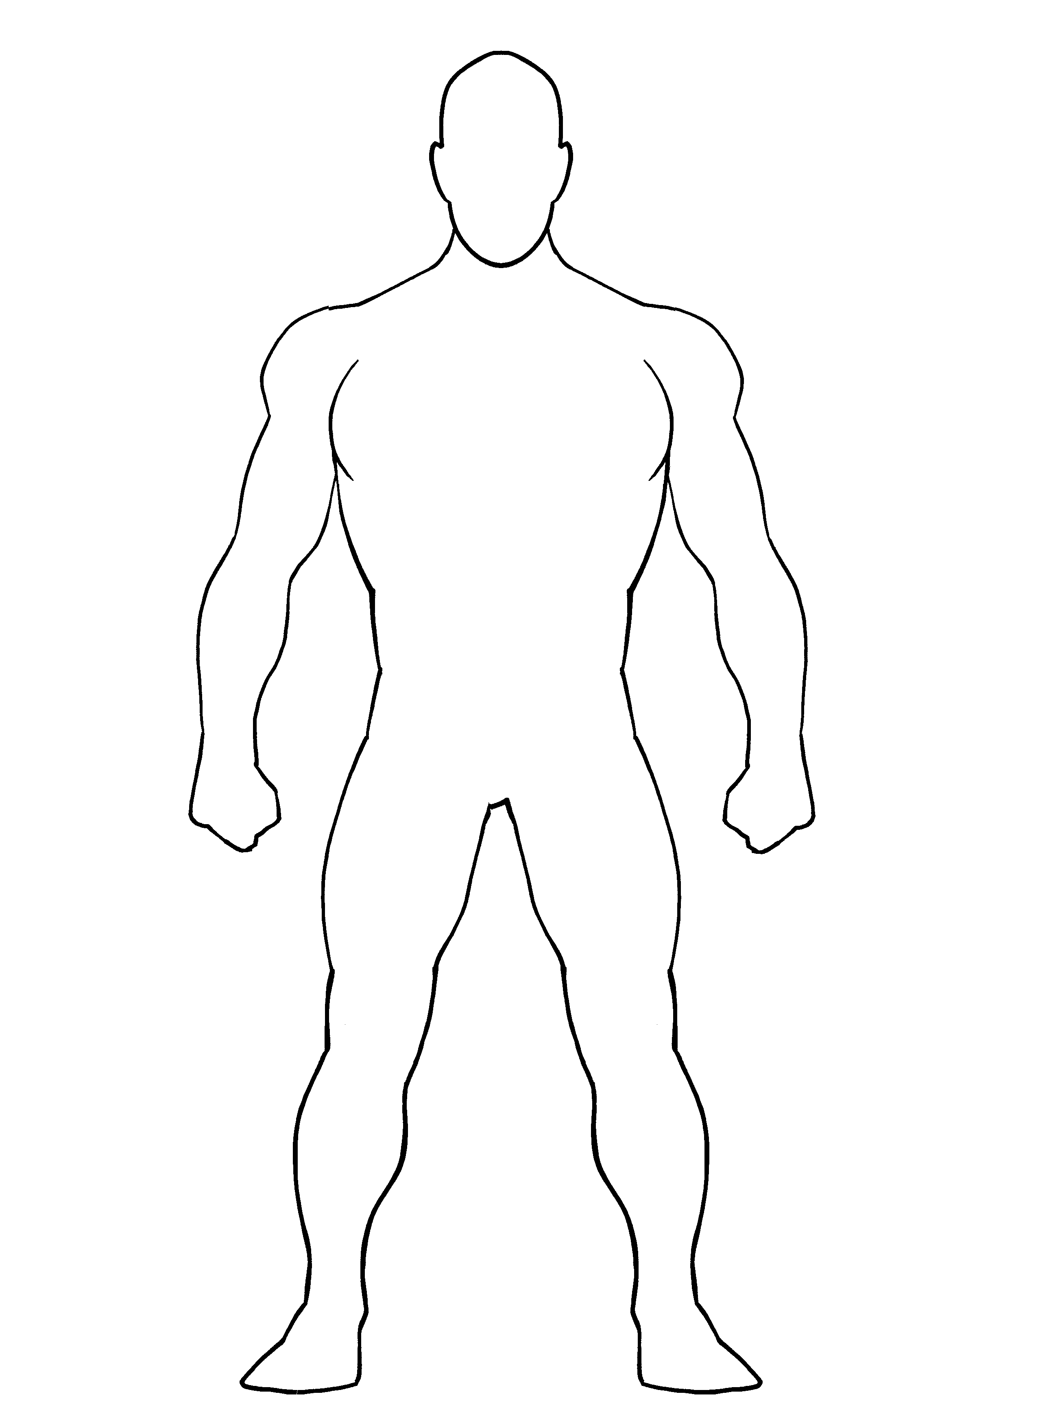
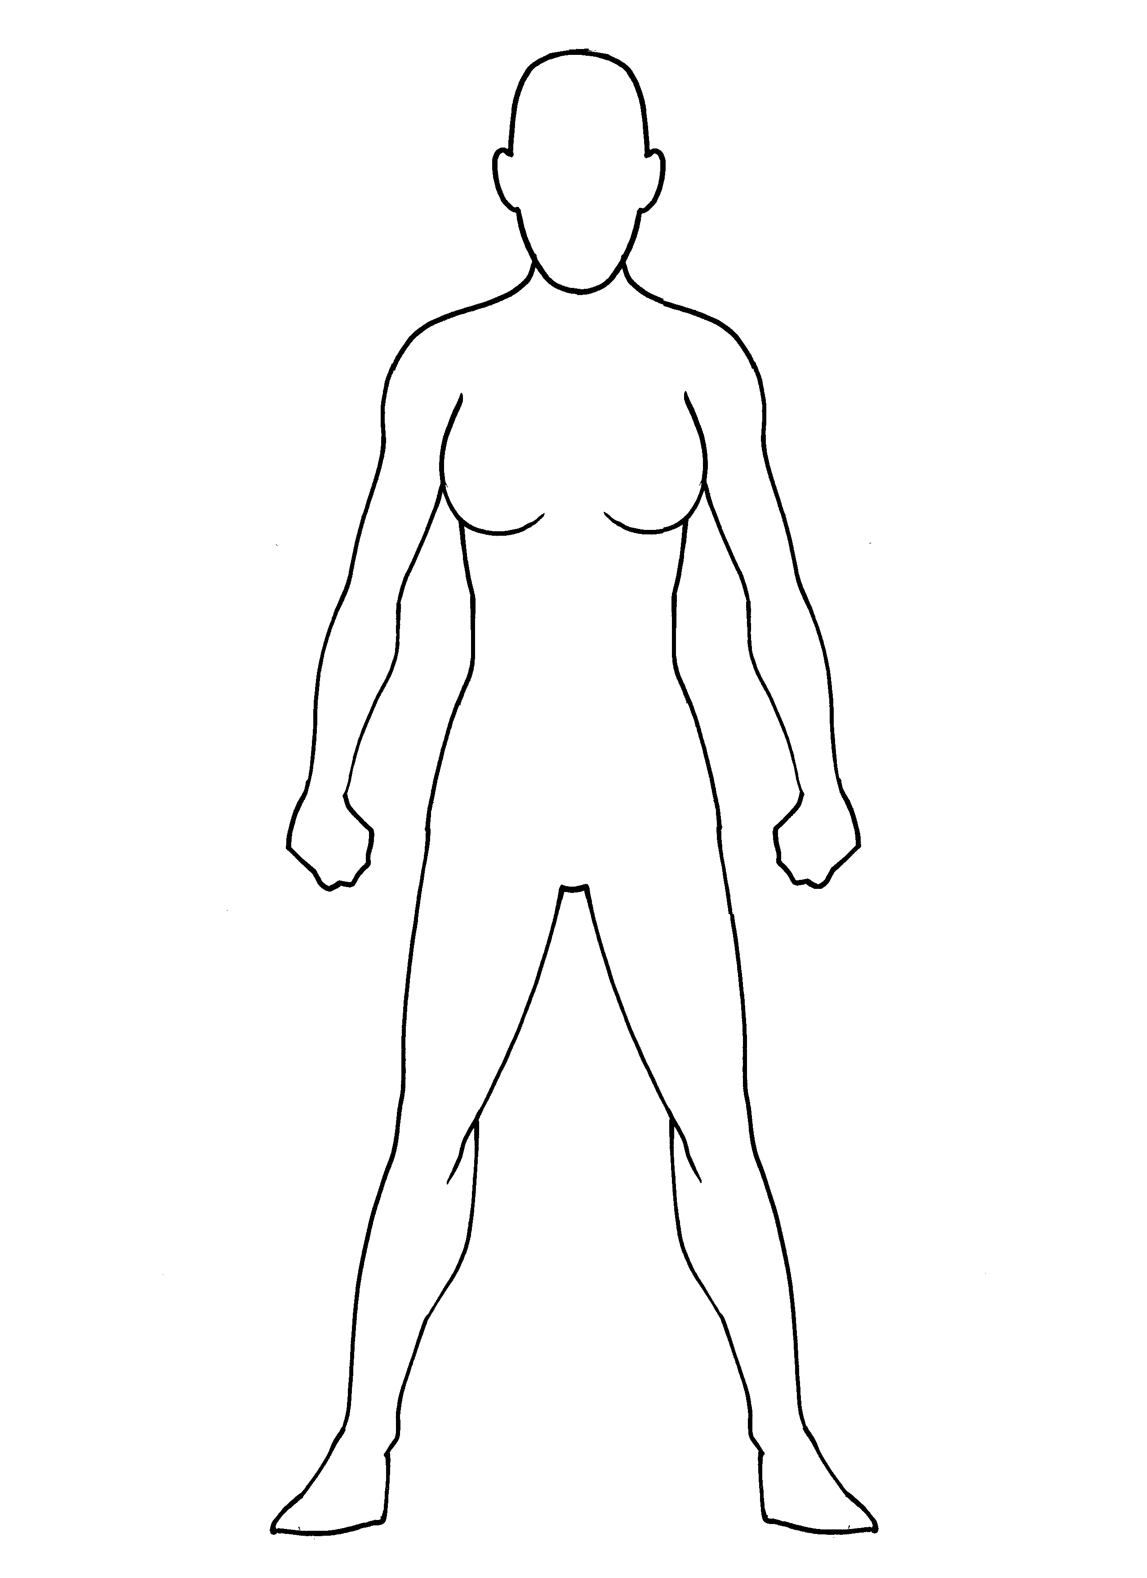

Name ______________________________Period______Date_________________________________________

Element Superhero/Villain Project Rubric
Project due:________________________

 | EXCEEDING | MEETING | APPROACHING | BEGINNING | NO EVIDENCE | Level Earned
Character | Clear identity. Powers are very appropriate. | Clear identity. Powers are appropriate. | Identified, but powers are too general. | Hard to tell who the characters are or what powers are present. | No character is presented
Periodic Table Information | No errors noted. | 1-3 errors noted. | 4-5 errors noted. | More than 5 errors. | No information
Content | Properties of the element are clearly explained. | Properties of the element are explained. | Properties of the element are partially explained. | Properties of the element are not explained. | No content is presented
Drawing of Hero/Villain | Clearly shows character and powers. | Shows character and powers. | Adequate display of character and powers. | Poor display of character and powers. | No character drawn
Creativity | Project is excellent. Obvious, high quality effort is shown. | Project shows good effort and quality. | Project shows average effort and quality. | Poorly created, showing obvious signs of rushing or lack of effort. | No character or written assignment
Neatness/ Colorful | Presentation is neat and easy to read. Characters are colorful. | Presentation is moderately neat and has some color | Project is moderately neat, hard to read, and has very little color | Presentation lacks neatness, is difficult to read, and/or has no color | No character or written assignment
Total

Comments:_______________________________________________________________________________________________________________________________________________________________________________________________________________________________________________________________________________________________________________________________________________________________________________________________________________________________________________________________________________________________________________________________________________________________________________________________________________________________________________________________________________________________________________________________________________

Element Super Hero/Villain Worksheet Name: ___________________
Use this worksheet to help keep track of your thoughts.

Is it a superhero or a villain?
What is your character’s name?
What element gives the character its power?
Periodic Table Information | Element name:_________________________ Symbol: ______  Atomic Number: _________________Atomic Mass: ____________  Boiling Point: _____________ Melting Point: _______________  Family:______________ State at Room Temp: _______________  Other Characteristics/Properties (at least 2 chemical properties)  1. 5.  2. 6.  3. 7.  4. 8.
How is the element used? | Uses (You must have at least 2):  1.  2.
What powers does your character have? How did he/she get those powers?
What are the strengths and/or weaknesses of his/her powers based on the properties of the element?
What does the character look like (think about the color and state of the element)?
How old is he/she?
Where does your character live (where in nature)? Do they have a hideout?
Do they have an arch nemesis?
What additional elements could combine with your hero to make them more powerful?

