EMS Master Chef Hunter & Gatherer Menu Battle Project

Task:
Imagine that you are part of a tribe of Hunters & Gatherers. The chief has called for a feast to celebrate the abundant food sources in all of his lands, but is not quite sure what should be on the menu. He has decided that there must be a competition among the various tribes in his lands to determine what will be on the menu. Your tribe now looks to you to lead them to victory in the first ever EMS Master Chef Hunter and Gatherer Menu Battle Project. In order to be victorious, you will need to:
- Create a restaurant menu using the hunter/gather skills, tools, flora and fauna available to your tribe.
- Choose any theme for your menu (fast food, food truck, fine dining, buffet, delivery).
- Create a menu that only uses the ingredients available to your tribe.
- Make a three course menu including a beverage list.
Process:
- Spend a short amount of time (15 Mins) researching the environment that you live in, tools you have and food sources available.
- Design a list of dishes using the tools you have and the food sources you can hunt/gatherer.
- Turn the dishes into a menu.
- Remember that your menu should be visually appealing to both the eye and the stomach.

The Tribes:
There will be 6 different tribes competing, each with a different list of tools, flora, and fauna.
- Tribe 1: The Neanderthals
- Tribe 2: Pacific Island Hoppers
- Tribe 3: Australian Aborigines
- Tribe 4: North American Great Plains
- Tribe 5: South East Asian Coastal
- Tribe 6: Masai-Mara African Tribe

Tribe 1: Neanderthal Tribe
Location: French Alps 175,000 Years ago
Basic Tool Kit: stone, wood and bone.  - Fire (cooking)  - Knives  - Spears  - clubs  - Axe  - Bowls  - Scrapping tools  - Baskets  - Leather rope | 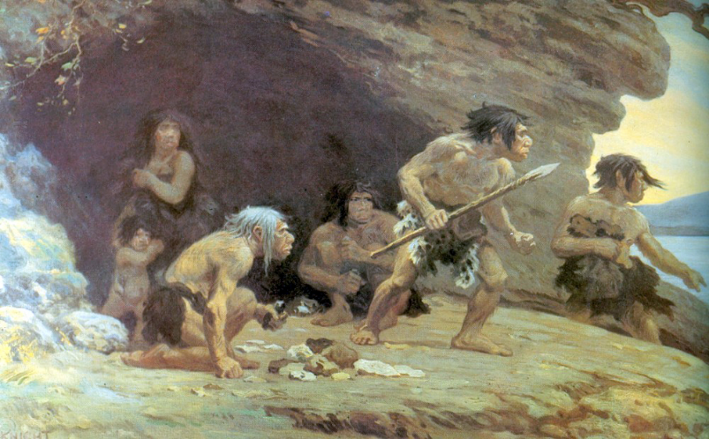

Fauna  68 species of mammals including chamois, ibex, hares, marmots , lynx , Irish elk , Mammoth, cave bear and wolves.  231 species of birds including: Crows, magpies, pigeons, owls, golden eagle. | Edible Flora  Chicory, sorrel, Pine nuts, strawberries, black berries, wild asparagus, Mushrooms.

TIP: Think Paleo!

Tribe 2: Pacific Island Hoppers

Location: Easter Island , Hawaii, cook Islands , Fiji, New Zealand, Tonga, Samoa. 2,000 years ago
Basic Tool Kit: Whale bone, Jade, stone, wood.  - Fire  - Spears  - Toothed/bladed clubs  - Knives  - Harpoon  - Net  - Line and hook  - Bowls  - baskets | 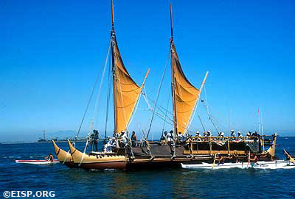  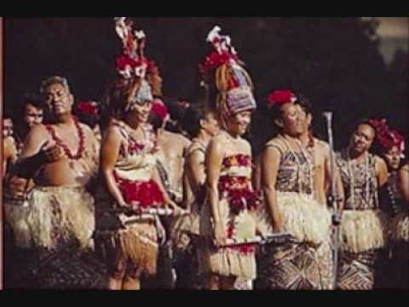

Fauna:  Moa, Dodo, mutton birds, Seal, penguin, whale, sea cow, flying fox, turtle, crab, clams, shrimp, reef fish, tuna, sea snail. | Edible Flora:  Yam, Taro, Banana, plantain, Coconut , pineapple, bread fruit, ferns, sugar cane.

TIP: Think All you can eat!

Tribe 3: Australian Aborigines

Location: Northern Australia and Papua New Guinea 50,000 years ago
- Tool Kit: Wood, Stone, Hide,  - Fire (hunting, Cooking)  - Spears + spear throwers  - Club  - Boomerang  - Fish trap  - Basket  - Bowl | 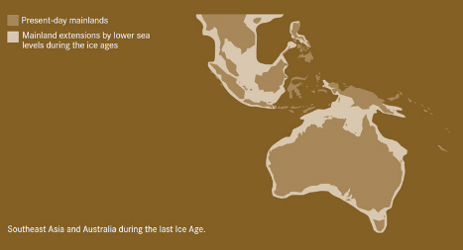  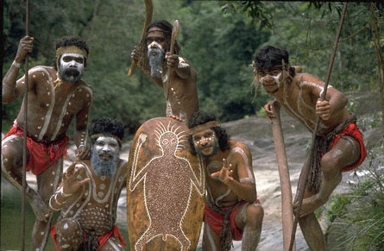

Fauna:  Australian Mega Fauna: (Giant versions of Kangaroo, Wombat, Goanna, turtle, magpie geese, python + several large flightless birds Thunder bird. Sea cucumber, Reef fish, Dugong, Oyster, Mussels, Bats, Bees, (honey), ants, grubs, termites. | Flora:  Gubinge, Green Plum, Pandanus, bush apple, Tamarind, wild passionfruit, Long Yam, Water Lily, Bulrush, Boab nut.

TIP: SURF & TURF

Tribe 4: North American Great Plains

Location: North American central great plains 12,000 years ago
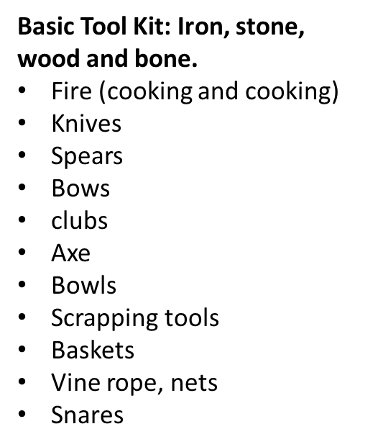 | 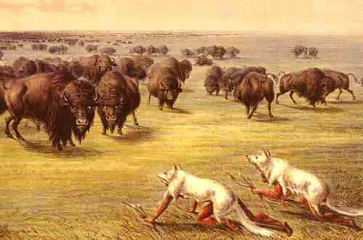

Fauna:  Pronghorn Deer, moose, Bison, Giant Beaver, grouse, turkey, Gopher, Mole, wood chuck, Prairie Dog, bat. | Edible Flora:  Prairie Turnip, groundnut, Yucca, Jerusalem Artichoke, Wild Onion, Sun flower, Lambs quarters, milkweed, wild Plum, New Jersey tea.

TIP: Super Size Me

Tribe 5: South East Asian Coastal

Location: River Mouth South East Asia 20, 000 Years ago
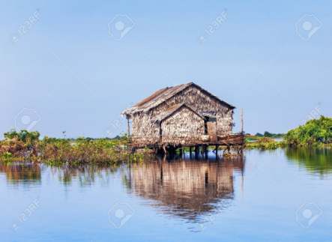

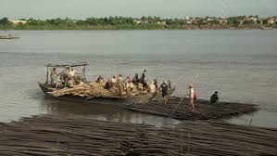

Fauna:  Fish, Eel, turtle, snake, shrimp, crab, grasshopper, tarantula, silk worm, water bug, bat, frog, toad, pheasant, duck, wild boar, ox. | Flora:  Mangosteen, Langat, Jackfruit, Wood Apple, Snake beans, chili, coconut, Star Fruit, dragon fruit, Durian, Banana, Bok Choi, soya bean, bitter melon, globe eggplant, squash, wombok, sesame, baby corn, carrot.

TIP: SEA FOOD SURPRISE

Tribe 6: Masai-Mara African Tribe

Location: Northern Kenya, East Africa, 10,000 Years ago
Basic Tool Kit: Iron, stone, wood and bone.  - Fire (cooking and cooking)  - Knives  - Spears  - Bows  - clubs  - Axe  - Bowls  - Scrapping tools  - Baskets  - Vine rope, nets  - Snares | 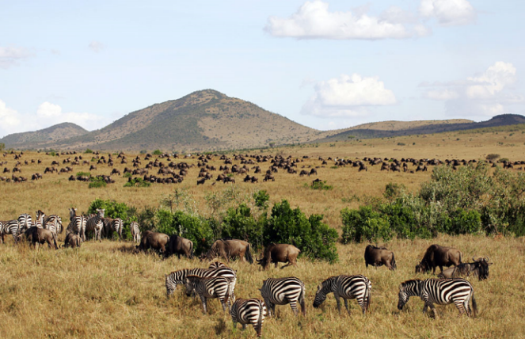  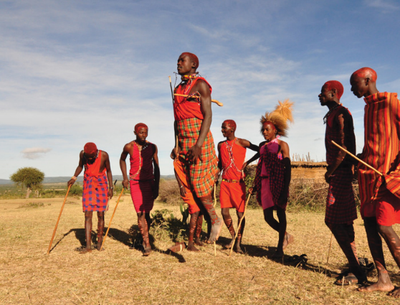

Fauna:  Elephant, Hippo, Wildebeest, Zebra, Giraffe, Gazelle, Pangolin, Buffalo, Warthog, Hare, Porcupine, mouse, Bat, Ostrich, Vervet monkey, Baboon, Termites, Bees ( Honey) | Edible Flora:  baobab nuts, Gingerbread plum, sour plum, Sausage Tree, Coffee bush, Okra, Melon, wild cucumber, Gourd.

Tip: Think African BBQ

EMS Master Chef Hunter & Gatherer Menu Battle Project Checklist

- Choose a theme for your menu: fast food, food truck, fine dining, buffet, delivery.
- Create a cover for your menu that includes:
  - The EMS Master Chef Logo
  - The name of your restaurant (be creative with this)
  - A picture or logo for your specific restaurant.
- Create a section on your menu for Appetizers that includes:
  - At least 3 different Appetizers (remember to be creative with the ingredients that you have access to).
  - A brief (one sentence) description of each dish.
  - A picture of at least one of the dishes in this section.
  - A price for each of the dishes.
- Create a section on your menu for Soups & Salads that includes:
  - At least 3 different Soups & Salads (remember to be creative with the ingredients that you have access to).
  - A brief (one sentence) description of the dish.
  - A picture of at least one of the dishes in this section.
  - A price for the dish.
- Create a section on your menu for Main Course Entrees that includes:
  - At least 3 different Main Course Entrees (remember to be creative with the ingredients that you have access to).
  - A brief (one sentence) description of each dish.
  - A picture of at least one of the dishes in this section.
  - A price for the dish.
- Create a section on your menu for Desserts that includes:
  - At least 3 different Desserts (remember to be creative with the ingredients that you have access to).
  - A brief (one sentence) description of each dish.
  - A picture of at least one of the dishes in this section.
  - A price for the dish.
- Create a section on your menu for Beverages that includes:
  - At least 3 different Beverages (remember to be creative with the ingredients that you have access to).
  - A brief (one sentence) description of each dish.
  - A picture of at least one of the dishes in this section.
  - A price for the dish.
- Finally, make sure your menu has plenty of bright, bold color, and is neatly done.
This will be due on Wednesday, February 14, 2018.
EMS Master Chef Hunter & Gatherer Menu Battle Project Rubric

Claim | Exceeding | Meeting | Approaching | Beginning
Recall and synthesize unit content knowledge to communicate ideas about the world. | Student can accurately recall 95% or more of content in unit as evidenced by teacher determined assessment. | Student can accurately recall 75% - 94%of content in unit as evidenced by teacher determined assessment. | Student can accurately recall 51% - 74% of content in unit as evidenced by teacher determined assessment. | Student can accurately recall 50% or less of content in unit as evidenced by teacher determined assessment.

Evidence | Exceeding | Meeting | Approaching | Beginning
Find evidence in order to defend a claim. | Given a source(s) student can identify two pieces of evidence that clearly support a claim. | Given a source(s) student can identify one piece of evidence that clearly supports a claim. | Given a source(s) student can identify one piece of evidence that attempts to support a claim. | Given a source(s) student can identify one piece of evidence.

Reasoning | Exceeding | Meeting | Approaching | Beginning
Justify (Explain) claims with evidence from primary and secondary sources. | Justifies claims using at least two appropriate, direct pieces of evidence from a set of teacher provided sources. | Justifies claims using at least one appropriate, direct piece of evidence from a set of teacher provided sources. | Justifies claims using at least one appropriate, direct piece of evidence from a set of teacher provided sources with teacher guidance. | Justifies claims using generalizations, with limited or no appropriate, direct evidence.

