Everything You Ever Wanted to Know About Expansion and Interconnection

Why Did Civilizations Expand Video Questions
Questions | Notes
What caused civilizations to expand?  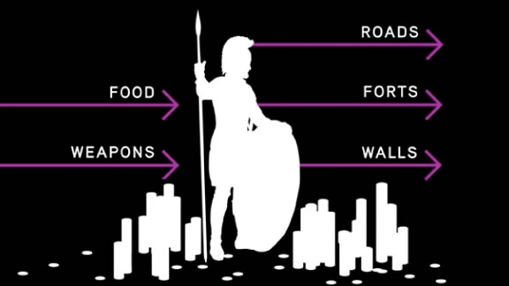  Click on the picture to start the video. | - 1:58 Why did civilizations expand geographically?  .  - 2:35 Why did many leaders of agrarian civilizations choose conquest to pay their expenses rather than trying to raise money in lands they already controlled?  - 3:04 What are some examples of ways that military innovations supported trade and other important human activities?
Summary (What is the BIG idea presented in the video):

Crash Course: The Modern Revolution Video Questions
Questions | Notes
What was the modern revolution and why was it important in shaping today’s societies?  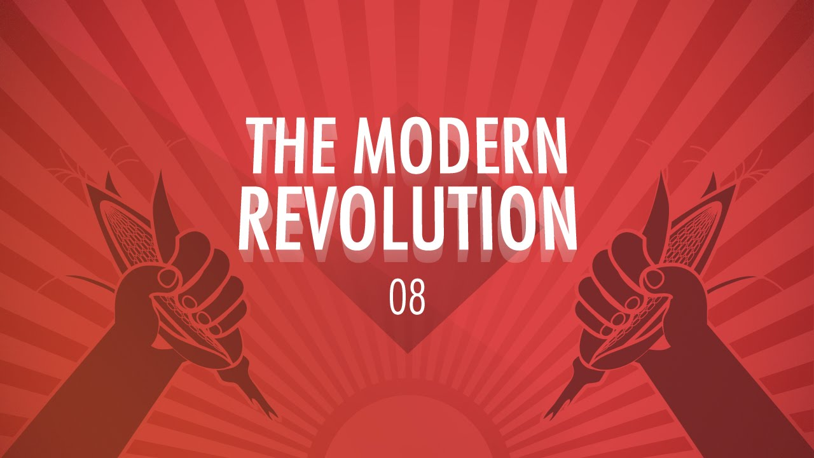  Click on the picture to start the video. | - 2:51 Why did European explorations to other areas of the world mark a significant change to collective learning and why did these explorations begin in the mid- to late-fifteenth century?  - 4:20 The connection of the four world zones was immediately profitable for Europeans and some others, but what were some of the negative effects?  - 7:56 How is the Industrial Revolution the result of years of collective learning?  - 8:30 How did the Industrial Revolution spark a different kind of adaptive radiation?  - 12:08 Why did industrialization begin in Great Britain and not in some other part of the world?
Summary (What is the BIG idea presented in the video):

4 World Zones Reading Questions
Questions | Notes
What are the 4 word zones and how are they similar and different from each other?  Click the picture to open the reading.  Click here for the audio recording of the reading. | - What is a world zone?  - What advantages did the Afro-Eurasian world zone have over the other world zones?  - What were some of the disadvantages that the Australasian and Pacific world zones faced?
Summary (What is the BIG idea presented in the reading):

Crash Course Big History: Why Early Globalization Matters Video Questions
Questions | Notes
How and why did early globalization impact the development our today’s societies?  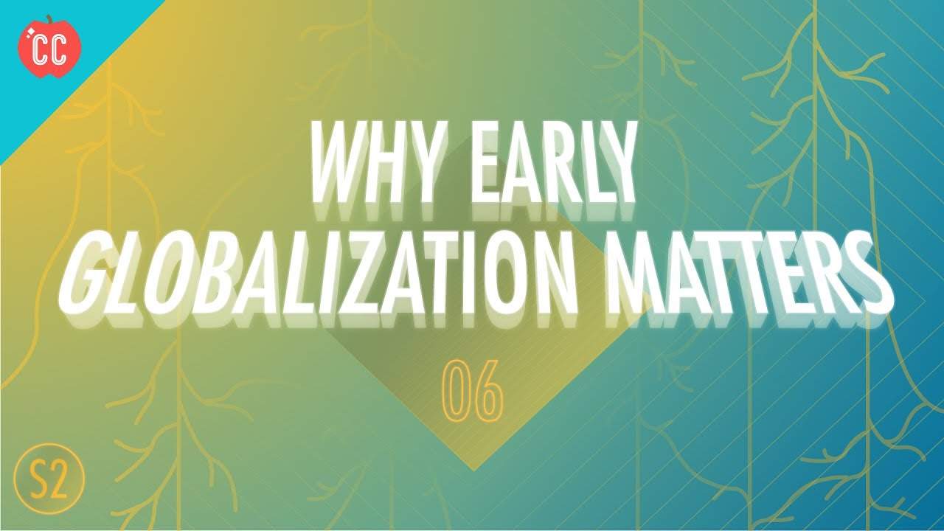  Click the picture to play the video. | - 1:12 What are two vital ingredients for collective learning to occur, and how might they vary?  - 3:46 How did Afro-Eurasia have more collective learning advantages than other world zones?  - 4:00 What happened 500 years ago that qualifies as “early globalization”?  - 7:03 Why is printing important to collective learning?  - 8:50 How did the potato affect the number of potential innovators around the world?  - 10:56 How are plagues a result of globalization, and what effect do they have on collective learning?
Summary (What is the BIG idea presented in the video):

H2 Brain Boost Video Questions
Questions | Notes
How did caffeine impact the develop of trade and colonization?  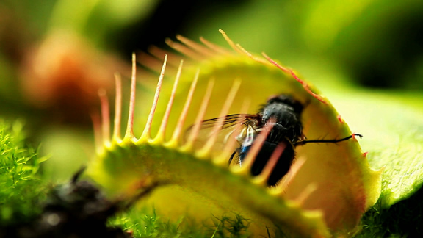  Click on the picture to start the video. | - 2:22 What are the differences between what traditional history and Big History say about the Boston Tea Party?  - 4:15 Why were the British able to control a vast network of trade designed to move tea around the world, launching and era of unprecedented global trade?  - 6:30 What elements make up caffeine and what other chemical is caffeine similar to?  - 7:22 How did caffeine impact politics, and what are some examples of this?  - 9:13 How does Big History link caffeine addiction to the origins of life?  - 13:48 Why is caffeine a deadly poison for some things but not others?  - 15:04 Why did a booming caffeine trade develop all over the world in the seventeenth century?  - 18:50 How does caffeine relate to colonization?  - 20:35 Why did caffeine cause a huge surge in the population of Britain from 1700 to 1800?
Summary (What is the BIG idea presented in the video):

Crash Course World History: The Columbian Exchange Video Questions
Questions | Notes
What was the Columbian Exchange, and how did it impact the world?  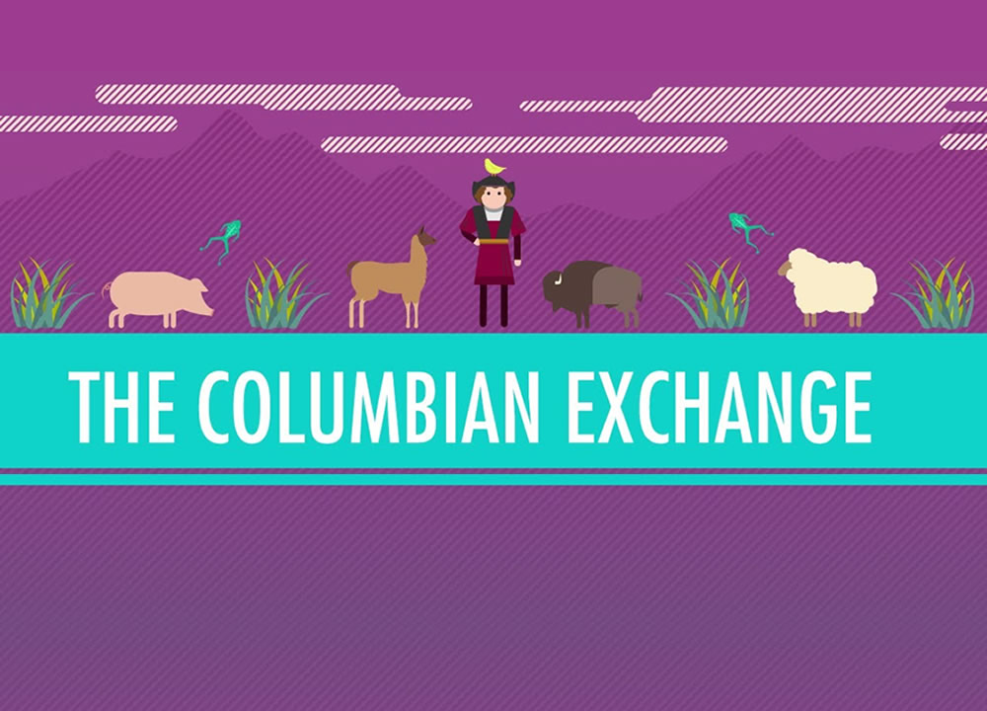  Click on the picture to start the video. | - 1:33 Into what four categories does John Green break the Columbian Exchange?  - 2:13 How many American Natives died as the result of the arrival of the Europeans? Why did they die?  - 4:20 Although it appears that most of the destruction that resulted from the Columbian Exchange was done by the Old World to the New World, what are the two things from the New World that negatively impacted the Old World?  - 7:25 How were animals that were brought from the Old World to the New World revolutionary for the New World?  - 8:36 How did New World plants have a large impact on Eurasia?  - 10:22 How did the Columbian Exchange impact the movement of people around the world?  - 11:22 Did Alfred Crosby (the writer of a famous book about the Columbian Exchange) think the Columbian Exchange was good or bad? Why?
Summary (What is the BIG idea presented in the video):

Investigating the Consequences of the Columbian Exchange Reading Questions
Questions | Notes
What positive and negative impacts did the Columbian Exchange have on the world?  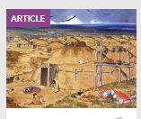  Click the picture to open the reading.  Click here for the audio reading. | - When and what was the Columbian Exchange?  - What are some of the things that moved east during the Columbian Exchange?  - What are some of the things that moved west during the Columbian Exchange?  - What were some of the intentional and what were some of the unintentional exchanges from this time?  - What is “the great dying”?  - According to the table in the reading, what were the main population trends in each of the regions listed from 1400 to 1700?  - How did the author come to her conclusions about the population changes during the Columbian Exchange?  - What does the author list as the consequences of the Columbian Exchange?
Summary (What is the BIG idea presented in the reading):

When Humans Became Inhumane: The Atlantic Slave Trade Reading Questions
Questions | Notes
How and why did the Atlantic Slave Trade occur, and what are its lasting impacts on the world today?  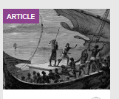  Click the picture to open the reading. | - Why were Africans the targets of slavery and not people from another area of the world?  - Who started the Atlantic slave trade and how long did it last?  - How do we know so much about how many Africans were enslaved and where they went during this time?  - What does the author mean when she writes, “the business of transporting slaves across the Atlantic had become a horrifying science.”  - What did the Atlantic slave trade ultimately do for Europe?
Summary (What is the BIG idea presented in the reading):

Jaqueline Howard: The History of Money Video Questions
Questions | Notes
What is the history of money, and what might be the future of money?  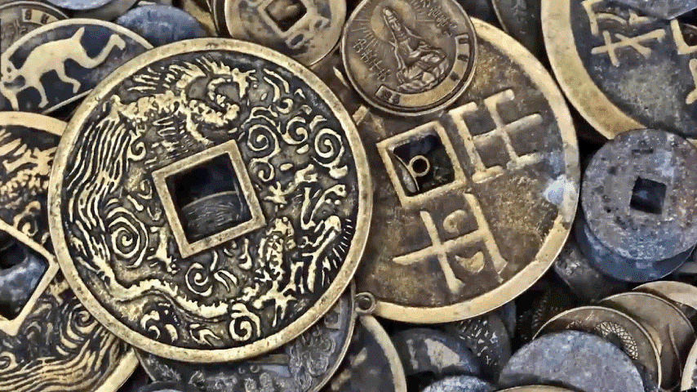 | - 0:58 Prior to money, what system of exchange was used to obtain necessary goods?  - 1:13 What were some of the first items to be bartered in early agricultural societies?  - 1:23 Why did bartering societies move toward systems of money?  - 2:12 What were some of the earliest forms of money?  - 2:46 When and where did paper money originate?  - 3:37 What brought about the use of credit as a system of monetary exchange?  - 4:01 What is the Gold Standard System?  - 4:23 The US dollar is fiat money. What does this mean?
Summary (What is the BIG idea presented in the video):

One Lump or Two: The Development of a Global Economy Reading Questions
Questions | Notes
What led to the development of a global economy, and how did this impact the world today?  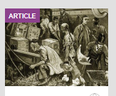 | - Why was trade with Asia severely limited in the early sixteenth century?  - What were the goods that went from the New World to Spain from 1493-1550?  - How do historians know what goods were being traded during this time?  - Why is it significant that mercury was being sent to the New World?  - What was the trans-Pacific trade, and who controlled this trade?  - Why was silver eventually devalued over the world, and how did gold not get devalued?  - Who was the original European importer of tea and how did the British end up taking that over?  - Why was beaver the most valuable fur in the fur trade, who had access to this type of fur, and what is our evidence for knowing this?
Summary (What is the BIG idea presented in the reading):

Systems of Exchange and Trade Video Questions
Questions | Notes
Describe how systems of exchange and trade develop, and how they impact today’s world?  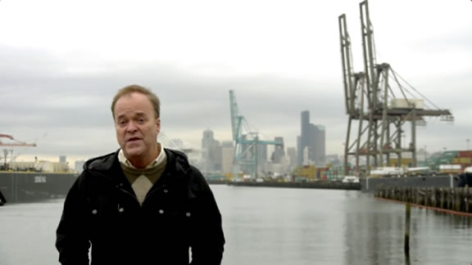 | - 1:19 What made the explosion of trade possible?  - 2:25 What led to the initial demand that drove the creation of the Silk Road?  - 3:22 What ended the Silk Road era?
Summary (What is the BIG idea presented in the video):

The First Silk Roads Reading Questions
Questions | Notes
Describe the history of the Silk Road, and how it has shaped history?  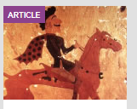 | - Why was the linking of different civilizations through networks of exchange and trade an important process?  - What characteristics were important for the smooth operation of the Silk Road and which empires maintained these characteristics?  - What are some of the goods that were in high demand and traded throughout the Afro-Eurasian world zone?  - What innovations in transportation technology made trade on the Silk Road possible?  - Why did the Silk Road decline after the third century CE?  - Why did the Silk Roads revive after the seventh century CE?  - What effect did the Silk Roads and other networks of exchange and trade have on the development and power of the four world zones?
Summary (What is the BIG idea presented in the reading):

Lost on the Silk Road Reading Questions
Questions | Notes
What were some of the dangers that were faced by early traders along the Silk Road?  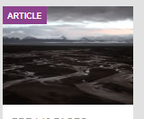 | - What are some of the challenges that Stark and his wife face throughout the story?  - How do you think traders, leading yaks loaded down with 300 pounds of goods, would have met these challenges?  - According to Stark, what were some of the goods, both material and nonmaterial, that were traded back and forth on the Silk Road?
Summary (What is the BIG idea presented in the reading):

