Everything You Ever Wanted to Know About Life
As you watch the each of the videos, answer the following questions:
A Big History of Everything: Life
Questions | Notes
How did life emerge on Earth? | - 0:58 What do most people believe is the reason for the emergence of life on Earth?  - 1:51 What is the biological blueprint for everything that exists?  - 2:05 What is the earliest form of life?  - 5:32 Why is the egg a critical development?  - 7:49 What did the extinction of the dinosaurs clear the way for?  - 9:32 What did humans ultimately evolve from?  - 11:55 How did primates take the first step toward being human?
Summary (What is the BIG idea presented in the video):

How Did Life Begin and Change Video Questions
Questions | Notes
How did life begin on Earth, and how did it change?  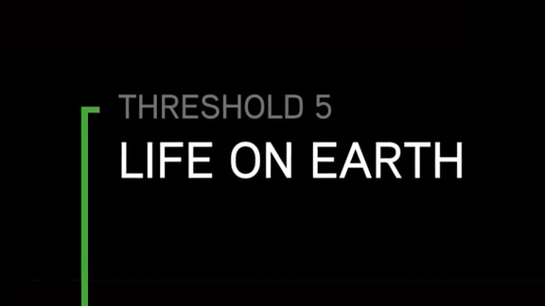 | - 4:16 What are the Goldilocks Conditions for life?  - 4:51 What makes rocky planets ideal locations for the appearance of life?  - 5:07 Why do many scientists believe that life may have originated deep in the oceans around oceanic vents?
Summary (What is the BIG idea presented in the video):

Mini-Thresholds of Life Video Questions
Questions | Notes
What are the various mini-thresholds of life on Earth?  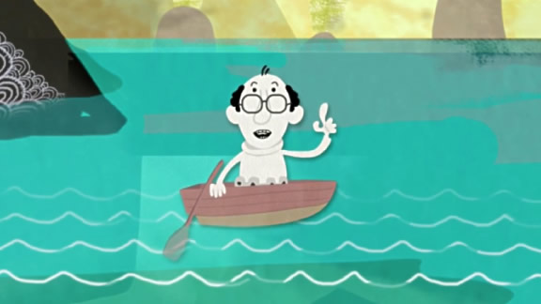 | - 1:12 What makes the emergence of photosynthesizing cells a mini-threshold?  - 1:58 What makes the emergence of eukaryotes a mini-threshold?  - 3:00 What makes the emergence of multi-celled organisms a mini-threshold?  - 3:37 What makes the emergence of brains a mini-threshold?  - 4:13 What makes the move of sea creatures to land a mini-threshold?  - 5:03 What makes the emergence of mammals a mini-threshold?
Summary (What is the BIG idea presented in the video):

