Everything You Ever Wanted to Know About Plate Tectonics Questions
Our Shifting Globe Video Questions
Questions | Notes
What are plate tectonics, and why should we be concerned about them? | - 1:00 What is a tectonic plate and what are some of the characteristics of the Earth’s plates?  - 1:38 What special role do oceanic plates play in the story of the Earth?  - 1:43 What drives the movement of the tectonic plates?  - 2:43 What causes earthquakes?  - 3:29 What did the surface of the Earth look like 250 million years ago?  - 4:16 How long did it take for the Earth to take on the appearance it has today, and how fast did the plates move?
Summary (What is the BIG idea presented in the reading):

Why We Are All Lava Surfers Reading Questions
Questions
How do plate tectonics impact our lives today? | - Why does Peter Stark call us “lava surfers”?  - Why are there so many earthquakes in Indonesia?  - What creates the geysers at Yellowstone National Park?  - Why does Stark describe the Earth as “new” as he views the volcano?
Summary (What is the BIG idea presented in the reading):

Intro to Geology Video Questions
Questions
What is geology, and how does it help to tell the story of Big History?  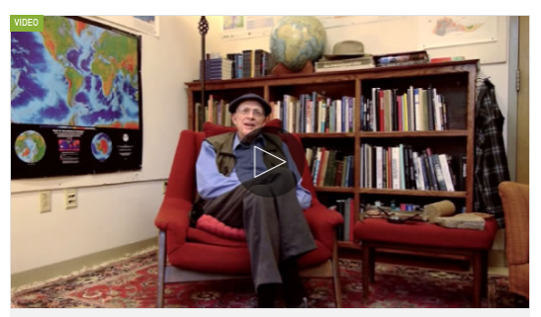 | - 1:44 According to Professor Alvarez, what are the two major types of geologists?  - 2:47 Why does the Professor Alvarez say that “atmospheres and oceans forget but rocks remember”?  - 4:00 What are the different types of tools that geologists use to study rocks?  - 5:44 What kinds of questions do geologists try to answer by studying the rock record?  - 6:26 What, according to Alvarez, is the most important question a geologist can ask?
Summary (What is the BIG idea presented in the video):

Alfred Wegener & Harry Hess Reading Questions
Questions
How did we prove that the continents are moving? | - What is continental drift?  - What types of evidence did Wegener have to support his theory of continental drift?  - Why were many scientists reluctant to accept Wegener’s idea of continental drift?  - What evidence did Hess find to support Wegener’s theory?  - What other discoveries supported the work of Hess and other supporters of the idea of seafloor spreading?
Summary (What is the BIG idea presented in the video):

