Everything You Ever Wanted to Know About the Beginnings of Agriculture

Threshold 7: Agriculture Video Questions
Questions | Notes
What are the Ingredients and Goldilocks Conditions need for Threshold 7?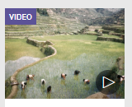 | - 0:17 How long ago did the last ice age end?  - 1:10 Why was human population growth after the ice age a problem for human communities?  - 1:33 Why was a warmer, stable climate important to the development of agriculture?  - 1:50 What is domestication?  - 2:10 Why does David Christian call agriculture an energy "bonanza" for humans?
Summary (What is the BIG idea presented in the video):

Why Was Agriculture So Important Video Questions
Questions | Notes
Why was agriculture so important?  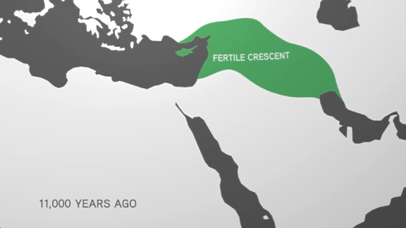 | Part I  - 1:12 How do the plants that humans choose to cultivate benefit from human attention?  - 2:04 What is symbiosis?  - 3:33 What does David Christian mean when he says that plants were changed by agriculture but that humans were changed, too?  - 4:32 When and where did farming begin?  - 5:09 Where did farming develop next?  Part II  - 5:55 Why did agriculture develop in so many places at about the same time?  - 6:20 Why couldn't humans just migrate to relieve population at the end of the ice age, just as they had always done?  - 7:12 How did the world's climate change at the end of the last ice age?  - 7:56 How did the ways Natufians lived differ from how foragers lived?  - 8:56 Why did people like the Natufians feel pressure to begin farming?  - 9:24 What does David Christian mean when he says that climate change made agriculture possible and overpopulation made it necessary?
Summary (What is the BIG idea presented in the video):

A History of Domestic Animals Video Questions
Questions | Notes
How have humans used animals to their advantage? | - 1:33 What animal was the first to be domesticated by humans? Approximately when did this take place?  - 2:25 How did domesticated dogs transition from their wolf-like origins over 10,000 years ago to the tremendous variety of breeds that exist today?  - 3:33 How did the domestication of animals affect the expansion of early civilizations around 10,000 years ago?  - 3:46 What immediate advantage did horses, camels, oxen, and donkeys give to the inhabitants of Afro-Eurasia over peoples living in the Americas?  - 4:05 What animals were first domesticated in the Americas?
Summary (What is the BIG idea presented in the video):

Collective Learning Part 2 Reading Questions
Questions | Notes
How and why did collective learning increase because of agriculture? | - What is a network?  - Why does size play an important role in collective learning networks?  - Why is diversity an important factor in collective learning networks?  - Why can an uneven distribution of information and connectedness lead to uneven distribution of wealth and power in collective learning networks?
Summary (What is the BIG idea presented in the reading):

Collective Learning Part 2 Reading Questions
Questions | Notes
How have various different disciplines helped to enhance our understanding of early agriculture? | - What are the four factors archaeologists use to determine where to dig?  - What evidence have archaeologists found in Banpo that gives them information about early farming practices there?  - What is an archaeobotanist?  - How do we know that the squash found from the Guilá Naquitz cave is the same species as the modern pumpkin and the summer squash?  - How did farming in Australia look different from farming in East Asia and Mexico?  - What are the conclusions the author draws from the three cases?
Summary (What is the BIG idea presented in the reading):

