Everything You Ever Wanted to Know About the Formation of Earth and the Solar System Questions Part 2
How Our Solar System Formed Reading Questions
Questions | Notes
How did our solar system and the Earth form? | - How did the Earth form?  - Was the process driven by small particles being drawn together or by large masses colliding together?  - How old is our Solar System?  - How are rocky planets different from gas planets?  - How is the Earth different from the other rocky planets?  - How did our Moon form?  - How does the Moon impact life on Earth?
Summary (What is the BIG idea presented in the reading):

What Was Young Earth Like Video Questions
Questions
What were the conditions like on the early Earth?  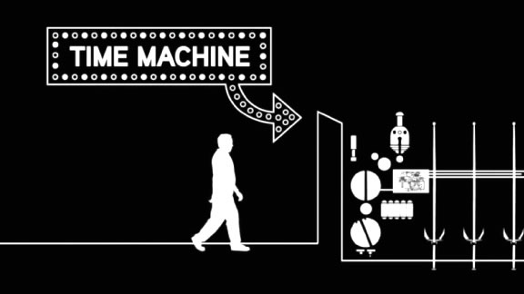 | Part I  - 1:08 What challenges would humans have faced if they lived on the early Earth?  - 2:23 Why was the early Earth so hot?  - 3:57 Why is it important that the inner core of the Earth is metal?  - 4:18 How is the mantle different from the core of the Earth?  - 4:40 How is the crust different from the mantle?  - 4:47 How did the Earth’s atmosphere form?  Part II  - 6:18 What important hypothesis did Alfred Wegener make about the Earth, and what was his evidence?  - 6:33 What was this supercontinent called?  - 7:04 Why were many scientists unwilling to accept Wegener’s hypothesis?  - 7:59 When and how did an explanation for the movement of the Earth’s plates come together?  - 8:57 How does continental crust differ from oceanic crust?  - 9:37 How were the Andes and Himalayas formed?  - 10:59 What is plate tectonics?
Summary (What is the BIG idea presented in the video):

The Early Atmosphere Video Questions
Questions
What was the atmosphere of early Earth like?  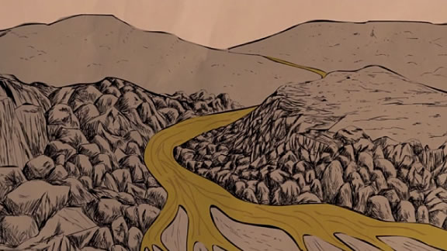 | - 0:37 How did the first atmosphere of the Earth form?  - 0:48 What is the “greenhouse effect,” and how did the conditions on the early Earth allow for its development?  - 1:41 How did the formation of the Moon impact the Earth?  - 2:11 How did the Earth’s atmosphere change during the Hadean eon?  - 3:07 How did the Earth’s atmosphere change during the Archaean eon?  - 3:55 What was the Great Oxidation Event and why did it happen?  - 4:50 How did the buildup of oxygen in the atmosphere impact that Earth’s climate?
Summary (What is the BIG idea presented in the video):

