Everything You Wanted to Know About New Chemical Elements Video Questions 2019
As you watch the each of the videos, answer the following questions:
Threshold 3: New Chemical Elements
Questions | Notes
How did we get elements beyond Hydrogen and Helium? | - 1:04 What are the Goldilocks Conditions for new chemical elements?  - 2:10 What is a supernova?
Summary (What is the BIG idea presented in the video):

What Did Stars Give Us?
Questions | Notes
How were stars formed?  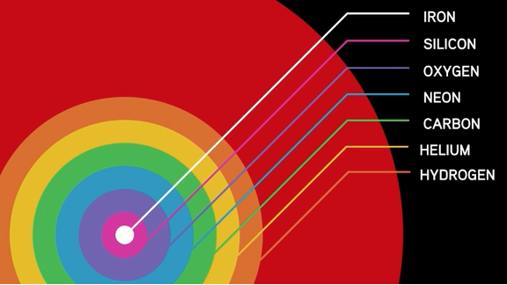 | - What happens at about 380,000 years after the Big Bang, and why is it important?  - As gravity begins to spin clouds of hydrogen (H) and helium (He), what is formed?  - What temperature is needed for stars to form?  - What is created inside dying stars? Give 3 examples.  - What is the heaviest element that dying stars can create?  - In order to create the heaviest elements, what needs to happen?  - Why did planets not exist during the first few generations of stars?
Summary (What is the BIG idea presented in the video):

A Little Big History of Silver Reading
Questions | Notes
How were stars formed? | - What characteristics of silver make it valuable as a mineral?  - Name a few places where silver was found on Earth? Where was it scarce?  - Describe two uses of silver.  - Describe the role of silver in trade along the Silk Road.
Summary (What is the BIG idea presented in the reading):

