Everything You Wanted to Know About Star Formation Video Questions Answer Key
As you watch the each of the videos, answer the following questions:
How Were Stars Formed?
Questions | Notes
How were stars formed?  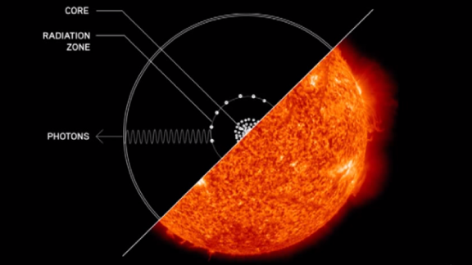 | - What was the universe like 200 million years after the Big Bang, and what is this time called?  - What was present in the universe at this time?  - What was the universe like at this time?  - Why was this a problem?  - What were the Goldilocks Conditions for stars to form?  - What is gravity?  - How are stars formed?  - What is the structure of a star?  - How has gravity shaped our universe?  - Why are there no super-superclusters?  - What does David Christian compare stars in the universe to?
Summary (What is the BIG idea presented in the video):

The expansion of the Universe enabled atoms and energy to spread out. This created small pockets of activity across an otherwise empty space. In these little areas, gravity pulled together atoms, and then more and more atoms, until the first stars came to life. Stars attracted other stars to form galaxies. Galaxies attracted other galaxies to form clusters, and then clusters came together to form superclusters.

How Were Stars Formed?
Questions | Notes
How were stars formed? | - What happens at about 380,000 years after the Big Bang, and why is it important?  - As gravity begins to spin clouds of hydrogen (H) and helium (He), what is formed?  - What temperature is needed for stars to form?  - What is created inside dying stars? Give 3 examples.  - What is the heaviest element that dying stars can create?  - In order to create the heaviest elements, what needs to happen?  - Why did planets not exist during the first few generations of stars?
Summary (What is the BIG idea presented in the video):

Before stars, the Universe was cold and dark. With gravity pulling at areas where there were just a few more atoms, clouds of atoms soon formed. These clouds got denser and denser until finally, the temperature got really, really hot – over 10 million degrees. At this point, atoms started fusing together and bam! A star is born.

