Everything You Wanted to Know About Star Formation Video Questions
As you watch the each of the videos, answer the following questions:
How Were Stars Formed?
Questions | Notes
How were stars formed?  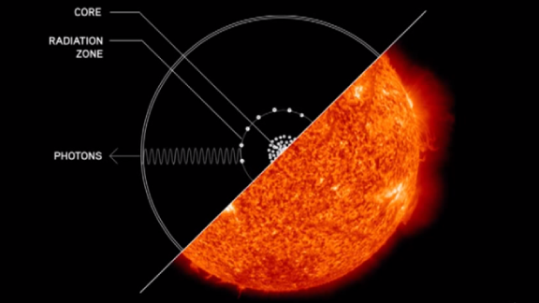 | - What was the universe like 200 million years after the Big Bang, and what is this time called?  - What was present in the universe at this time?  - What was the universe like at this time?  - Why was this a problem?  - What were the Goldilocks Conditions for stars to form?  - What is gravity?  - How are stars formed?  - What is the structure of a star?  - How has gravity shaped our universe?  - Why are there no super-superclusters?  - What does David Christian compare stars in the universe to?
Summary (What is the BIG idea presented in the video):

What Did Stars Give Us?
Questions | Notes
What elements are produced in aging and dying stars?  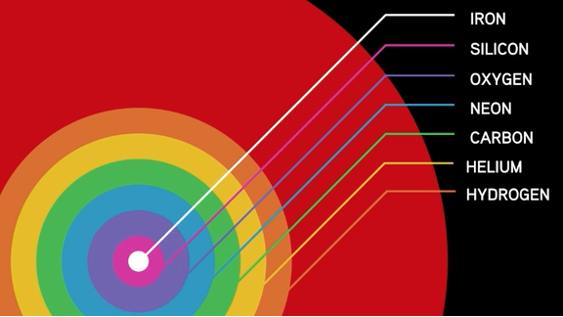 | - Where did all the other elements come from?  - What did the cooling of the universe allow?  - How hot is the surface of the sun?  - What temperature do you need to get Carbon? To get Iron?  - What happens as stars begin to run out of fuel?  - What is a supernova, and what does it do?  - What might the star of Bethlehem have been?  - Compare the percentage of Hydrogen and Helium to all other elements.
Summary (What is the BIG idea presented in the video):

