Everything You Wanted to Know About Star Formation Video Questions
As you watch the each of the videos, answer the following questions:
How Were Stars Formed?
Questions | Notes
How were stars formed?  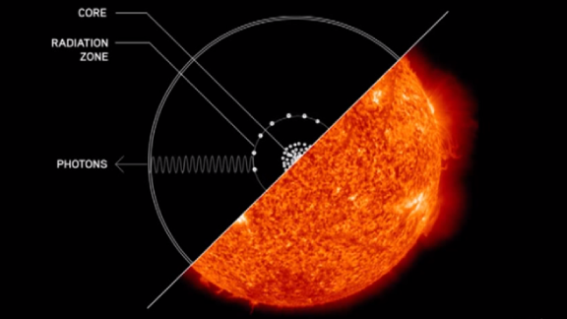 | - What was the universe like 200 million years after the Big Bang, and what is this time called?  - What was present in the universe at this time?  - What was the universe like at this time?  - Why was this a problem?  - What were the Goldilocks Conditions for stars to form?  - What is gravity?  - How are stars formed?  - What is the structure of a star?  - How has gravity shaped our universe?  - Why are there no super-superclusters?  - What does David Christian compare stars in the universe to?
Summary (What is the BIG idea presented in the video):

Threshold 2: Stars Light Up
Questions | Notes
What are the Ingredients and Goldilocks Conditions needed for stars to form?  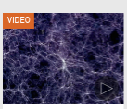 | - 0:30 What was the Universe like before the first stars formed? How long was it after the Big Bang before stars started to form?  - 1:30 Why do atoms packed together tightly heat up?  - 2:16 How long do stars continue releasing energy into space?
Summary (What is the BIG idea presented in the video):

A Big History of Everything - H2
Questions | Notes
How have stars impacted history?  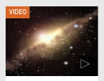 | - 1:57 What draws atoms of hydrogen and helium together into clouds?  - 2:54 What happens as these clouds get larger?  - 4:11 What was different about the Universe once stars arrived?
Summary (What is the BIG idea presented in the video):

