Directions: After reviewing the process of how stars formed, write the triggering event in the circle next to the question. Next, look at each circle and determine if the contents of the circle are a cause, a consequence, neither, or both!
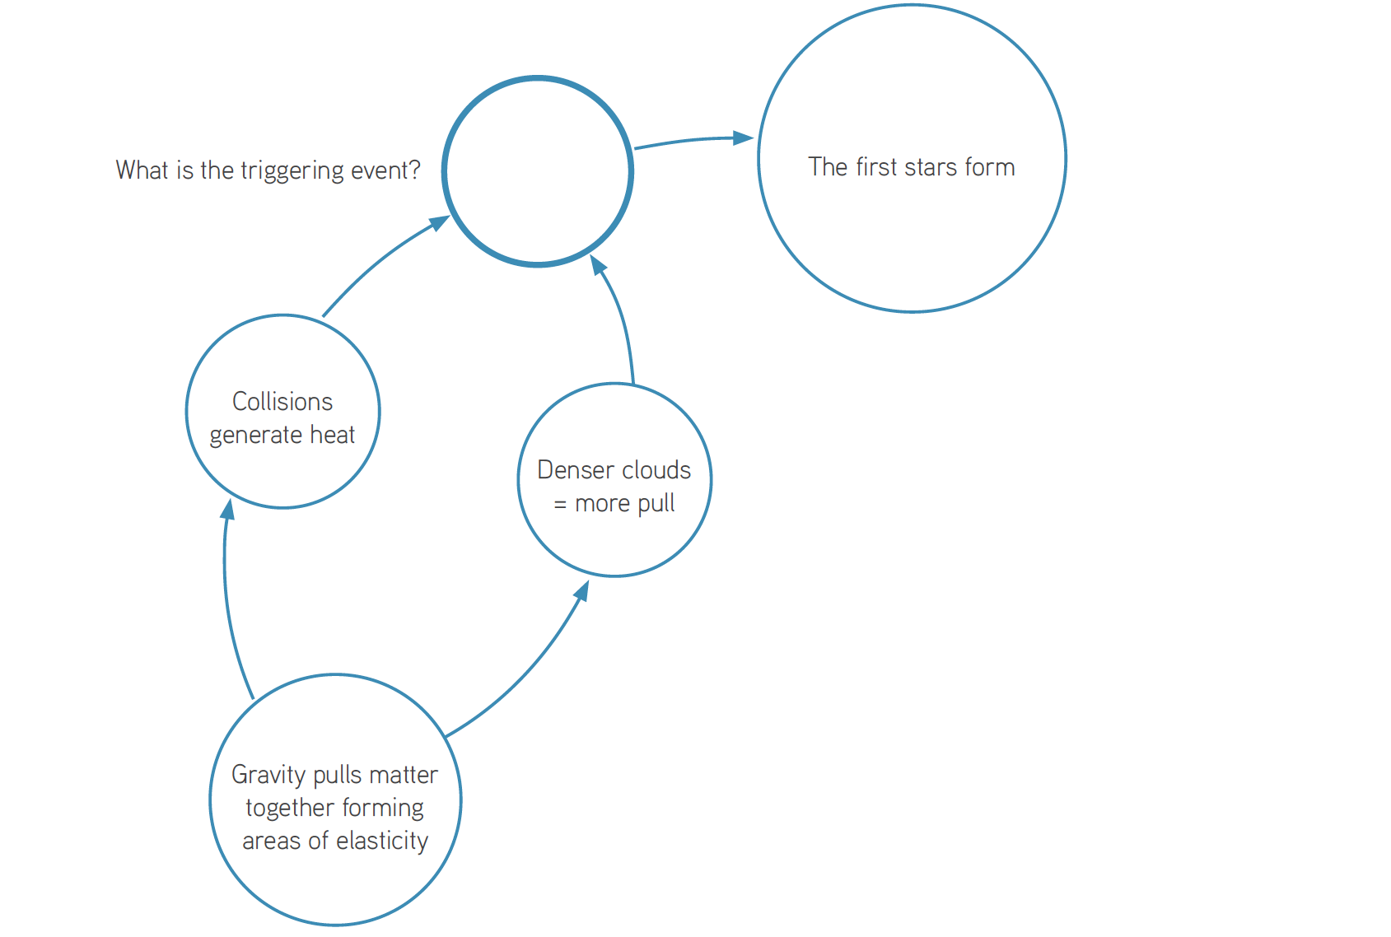
A Trigger Event is….
An example of a long-term cause is….
An example of a short-term cause is...

