History As Mystery: What Caused the Collapse of Easter Island? Graphic Organizer

Day 1:
As you examine and analyze the various documents for “History as Mystery: What Caused the Collapse of Easter Island?” complete the graphic organizer below.

Cause | Evidence | Source | Expert

CER: Critical Thinking Question

In your opinion, which of the causes listed above had the biggest impact on the collapse of Easter Island and why?

Claim:

Evidence:

Reasoning:

Scroll Down to see Grading Rubric
Work Habit | Meeting | Approaching | Beginning
I completed my work. | I attempted all parts of the assignment. | I attempted at least half of the assignment. | I started the assignment.

Evidence | Exceeding  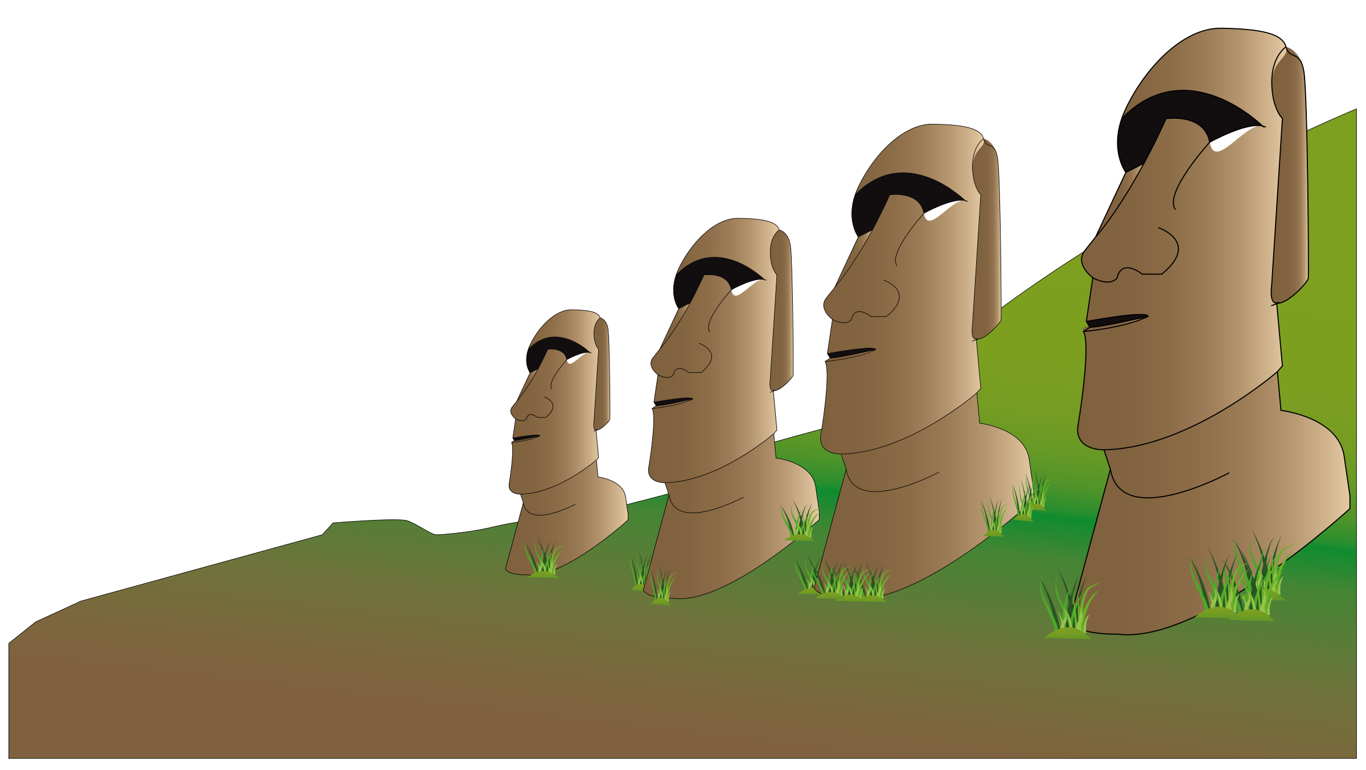 | Meeting | Approaching | Beginning
Identify | Student can identify the expert and new evidence found from both sources. | Student can identify the expert and new evidence found from at least 1 of the sources. | Student can identify the expert or new evidence found from the source(s). | Student attempts to identify the expert and evidence found from the source(s).

