History As Mystery: What Caused the Collapse of Easter Island? Graphic Organizer

Day 2:
As you examine and analyze some “new” documents for “History as Mystery: What Caused the Collapse of Easter Island?” complete the graphic organizer below.

Original Cause(s) | New Evidence | Source | Expert
Deforestation
Soil erosion (poor soil)
No boats for fishing or escaping
Civil War
Cannibalism
Slave Traders
Disease

CER: Critical Thinking Question

Should we look at Easter Island as a cautionary tale of human impacts on the environment, or the cautionary tale of humankind’s impacts on other humans, and why? Be sure to support your answer with specific evidence from the documents.

Claim:

Evidence:

Reasoning:

Scroll Down for Grading Rubric

Work Habit | Meeting | Approaching | Beginning
I completed my work. | I attempted all parts of the assignment. | I attempted at least half of the assignment. | I started the assignment.

Evidence | Exceeding  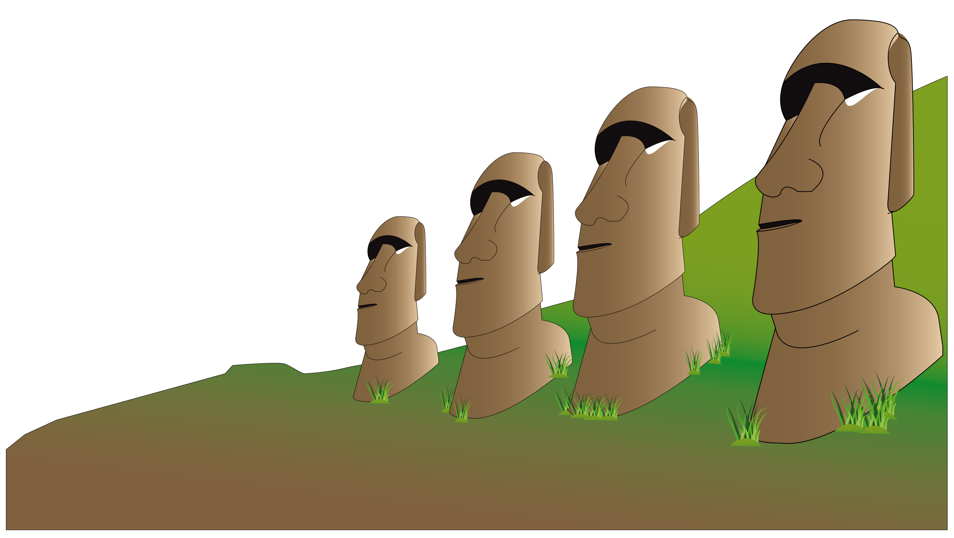 | Meeting | Approaching | Beginning
Identify | Student can identify the expert and new evidence found from both sources. | Student can identify the expert and new evidence found from at least 1 of the sources. | Student can identify the expert or new evidence found from the source(s). | Student attempts to identify the expert and evidence found from the source(s).

