NAME:____________________________________________________PERIOD:_________
Directions: Answer question #1 below after our classroom discussion.
Did your guess change after hearing your classmates?
1.) Based on the information you have – 80 skeletons, all male, buried in York, England about 1,800 years ago, many of them with heads cut off and placed near their feet – what do you think happened?

Directions: As you watch, The Mystery of the Headless Romans, answer question #2.
2.) Write down the name of the disciplines who have been involved in determining the age of the bodies and what happened to them. Be sure to write a brief description of what they do.
Name of Expert | Description

Directions: Read the short essay, What Will We Leave Behind?, and then answer question #3.
What Will We Leave Behind?
The bodies in York were buried 1,800 years ago, but dedicated researchers from several disciplines have been able work out many details of what happened, and about Roman life in general. What do you think our current society will look like to the historians of the future, once another 1,800 years go by? We have so much information recorded in so many ways by so many different people—and these people all have different perspectives on what the world is like. How much time will a history student in the class of 3800 spend on “The Information Age”—or whatever they call this sliver in time when electricity, computers, phones, and the internet came into people’s lives? They may only have one day for that lesson because there will be so many other things to cover.
What will they look at? Will it make us seem like a happy people? Will they learn about the things that caused stress and controversy in our culture, like racism or climate change or cancer, all of which may be foreign concepts by then? Will the things we value, such as democracy, chocolate, and education seem as strange to them as the Romans’ custom of burial decapitation seems to us?
But the historian in 3800 will have a very different problem looking at our world than we have when looking at the Romans. The Romans didn’t have the internet, television, printed books, nor any of the tools we use for recording and storing information. We have so little evidence about the Romans to go on, but future historians will have far too much information about us.
There is more information on one smartphone than all the information historians have ever collected about the Romans. And our modern world has billions of phones, computers, books, magazines, and newspapers, not to mention Wikipedia. Most of this will probably be available to future historians, but hardly manageable because there will be so much.
What information will they focus on as truly important? Twitter and instagram? Fortnite? Superhero films? Fast food restaurants?
Directions: Answer question 3 below by responding to each prompt.
3.) To solve the Mystery at York, may different experts were called in. In the year 3800, what type of experts do you think will be needed to discover the story of the era we are currently living in?

What evidence will they find?

What will historians think is truly important?

Claim | Exceeding  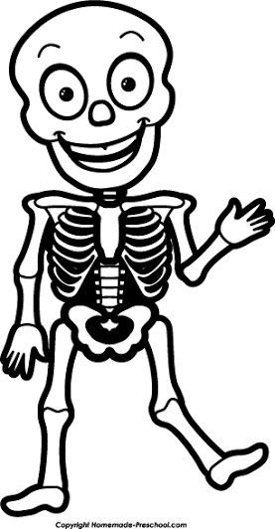 | Meeting  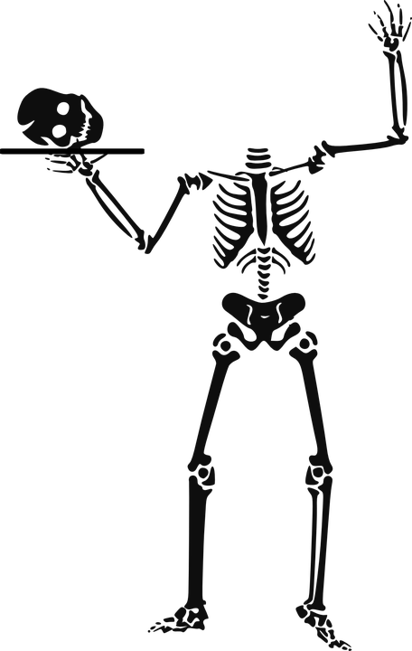 | Approaching  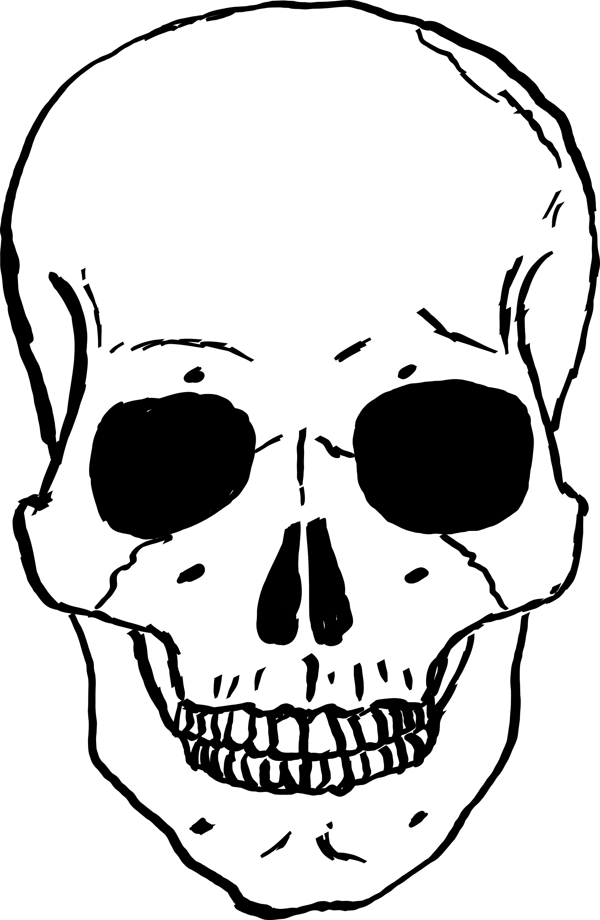 | Beginning
Making a claim to answer the question (s) | Student makes a claim that completely and accurately answers what experts would be needed to discover our era, what evidence they will find, and what historians will think is important.  *Accurate=Identify evidence/information found that truly reflects this era (2000s) in their response. | Student makes a claim that accurately answers at least 2 of the following questions: what experts would be needed to discover our era, what evidence they will find, and what historians will think is important.  *Accurate=Identify evidence/information found that truly reflects this era (2000s) in their response. | Student makes a claim that is partially accurate and answers at least 1 of the following questions: what experts would be needed to discover our era, what evidence they will find, and what historians will think is important. | Student attempts to make a claim about what experts would be needed to discover our era, what evidence they will find, and what historians will think is important.

