How and Why the Egyptians Made Their Mummies

A dead man stands trembling in the Hall of Truth. He is a noble man. Gods are all around him. They are ready to judge his life.
Seated before the man is Osiris. Osiris is the king of the dead. He has a glittering crown with gorgeous white feathers.
The man wonders if he will live forever. If not, he will he be fed to a god called the Eater of the Dead. How can he wonder about all of this if he's already dead? The man is actually in between death and life. His soul is waiting to be judged.
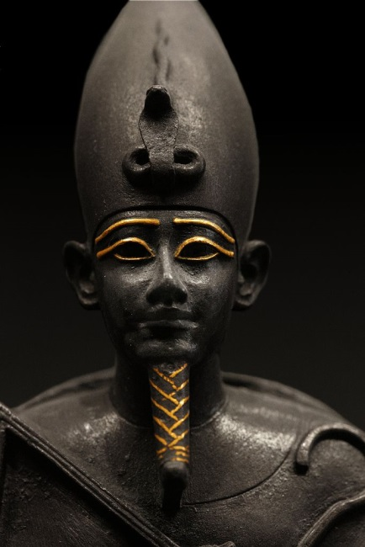
Osiris judges the man's life. He places the man's heart on one side of a scale. On the other side, he places a sacred feather. It represents the truth. If the two sides weigh the same, he will live forever. If the heart is heavy with lies or secrets, the Eater of the Dead will have the man for lunch.

Mummification
Egyptians thought the body was important in the afterlife. That's why they practiced mummification or the preservation of the dead.
Below are the steps of mummification.

1. Removal of the brain
The brain is taken out through the nose. It was not considered special.

2. Organ removal
The liver, lungs, and other organs are removed. They are dried out and stored. The heart is left in the body, so it can be weighed by Osiris.

3. Dehydration
The body must have the liquids removed to stop decay. The body is treated with a special salt called natron for 40 days. Afterward, it is washed and dried.

4. Stuffing
The empty body is stuffed with clothes or sawdust. The eyes are stuffed and painted black. The lips and cheeks are painted.

5. Oiling the body
The body is massaged, perfumed, and blessed with oil.

6. Coloring
After being stuffed, men are colored red and women are colored yellow.

7. Arrangement of the body
Bodies were arranged differently at different times in Egyptian history. The arms could be placed to the side of the body. They could also be folded on its chest. Some were placed with hands on shoulders.

8. Wrapping
The body is wrapped in fine linen. This process takes two weeks.

9. Funerary mask
A mask is fitted to the mummy's body. Sometimes it was made entirely of gold.
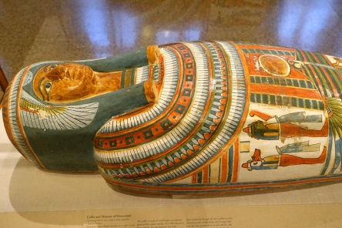

10. Burial of waste
Everything used to prepare the body is placed in a jar. It is buried separately.
The mummy is put in its coffin. It is buried with jewelry, games, furniture, food, and clothing. These things would be used in the afterlife.
How was the man judged by the great Osiris? Ask his mummy.

Quiz
1. Which sentence from the article explains WHY a dead man is trembling in the Hall of Truth?
A
A dead man stands trembling in the Hall of Truth.
B
He has a glittering crown with gorgeous white feathers.
C
The man is actually in between death and life.
D
His soul is waiting to be judged.

2. What is one reason why mummies were buried with jewelry, games, furniture, food and clothing?
A
Egyptians believed these would be used in the afterlife.
B
These items were gifts for the Gods.
C
Egyptians valued these objects more than the brain.
D
These items decorated the coffin.

3. What is the purpose of the section “Mummification”?
A
to explain how Osiris judged Egyptians' lives
B
to describe how Egyptians mummified bodies
C
to explain how men and women were mummified differently
D
to describe how we know about mummification

