How Did Life Begin and Change Video Questions
As you watch the each of the videos, answer the following questions:
How Did Life Begin and Change Video Questions
Questions | Notes
How did life begin on Earth, and how did it change?  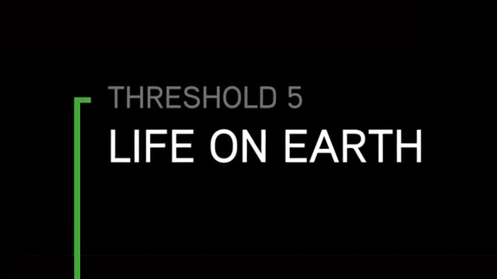 | - 4:16 What are the Goldilocks Conditions for life?  - 4:51 What makes rocky planets ideal locations for the appearance of life?  - 5:07 Why do many scientists believe that life may have originated deep in the oceans around oceanic vents?
Summary (What is the BIG idea presented in the video):

