How Our Solar System Formed Reading Questions
Questions | Notes
How did our solar system and the Earth form?  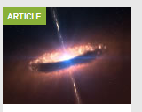 | - How did the Earth form?  - Was the process driven by small particles being drawn together or by large masses colliding together?  - How old is our Solar System?  - How are rocky planets different from gas planets?  - How is the Earth different from the other rocky planets?  - How did our Moon form?  - How does the Moon impact life on Earth?
Summary (What is the BIG idea presented in the reading):

