Driving Question: HOW AND WHY DID WE CHANGE OUR MINDS ABOUT THE UNIVERSE?
Purpose: The development of collective learning is a central theme not only in the Big History course, but in the history of ideas as well. “In science,” Carl Sagan once wrote, “it often happens that scientists say, ‘You know that’s a really good argument; my position is mistaken,’ and then they would actually change their minds and you never hear that
old view from them again.” In developing a “modern origin story,” Big Historians rely on the most compelling ideas from all the disciplines, acutely aware that these ideas often undergo profound change. A powerful example of this is the change in understanding of the Universe and our place in it from the geocentric/geostatic view to the heliocentric/geokinetic view.

Process: In studying Big History, you will meet many people who, like you, question their own thinking and beliefs. Like you, they sometimes change their minds about things they had long thought to be true. And, on occasion, the changes in their thinking and beliefs lead other people to raise new questions, to develop new answers, and maybe to even change their minds.
Many of the most important changes in the world, such as discovering cures for diseases or developing new forms of government, have happened because people came to new conclusions about what causes sickness or what is the best political system. However, it is not always easy to question your thinking or change your ideas, particularly if everyone around you believes the same thing and has done so for a very long time. And, changing one’s mind might not always lead to good results. Indeed, sometimes people make mistakes or change their minds unnecessarily.
So, this Investigation asks you to consider this important question: How and why do individuals change their minds? To help you think about this question, we are providing you examples of two people who changed their views on the structure of the Universe and our place in it: Copernicus and Galileo. Both men questioned beliefs that had existed for over 2,000 years. And both men contributed to a new way of thinking about the Earth’s place in the Universe.

Throughout history, most people thought that the Earth was at the center of the Universe and that it did not move. This is called the geocentric view of the Universe. Copernicus and Galileo questioned that view and argued that the Earth and the other planets revolved around the Sun. This is the heliocentric view.

So, why did Copernicus and Galileo change their minds? Can their cases help you develop an argument for when people should change their minds? How? Or do you think that their stories are not very helpful in answering this question?

Text 1: THE GEOCENTRIC VIEW
How did the Universe appear to our ancestors before the invention of the telescope? Most people thought the Earth was the center of the Universe. For them, the Earth did not move in the sky and it did not rotate on its axis. Rather, all the planets and stars rotated around the Earth. Historians and scientists call this Earth-centered view of the Universe geocentric (“geo” referring to the Earth and “centric” meaning in the center) and geostatic (“static” meaning unmoving).

The Greek astronomer Ptolemy (ca. 90–168 CE) described the geocentric view of the Universe in the Almagest, a book he wrote in about 150 CE. For more than 1,500 years, people accepted this view (pictured below) as the correct one. Why would an astronomer like Ptolemy hold a geocentric and geostatic view of the Universe? Why did so many of our ancestors accept this view? In the excerpt below, Carl Sagan, an American astronomer and cosmologist, explains

Ptolemy believed that the Earth was at the center of the Universe and that the Sun, Moon, planets and stars went around the Earth. This is the most natural idea in the world. The Earth seems steady, solid, immobile, while we can see the heavenly bodies rising and setting each day. Every culture leaped to the geocentric hypothesis.
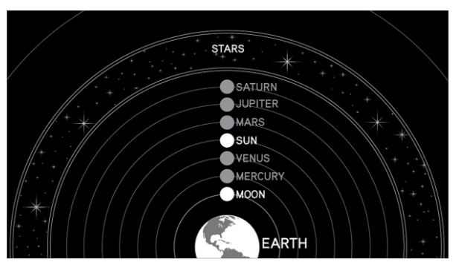

Text 2:PATH OF THE PLANETS
With only their eyes, our ancestors observed the heavenly bodies moving across the night sky. The Greeks called these heavenly bodies “planets,” which means wandering stars. They also noticed that sometimes the planets appear to go backward in the sky and even to do loop-de-loops. The picture below, a composite photo of shots taken of Mars from the same spot on the Earth once a week from early autumn 2009 to late spring 2010, shows how Mars appeared to reverse its course and then circle back on track. From the first picture, taken on October 2, 2009, Mars is the white dot on the far right hand side of the photograph. About three months later (December 22, 2009), Mars appears to go backward in the sky and moves in that direction until about mid-March, when it looks as if it is going forward again.

Scientists call this movement of the planets “retrograde motion.” “Retrograde” means backward. What do you think explains this unusual motion? How would our ancestors explain it?
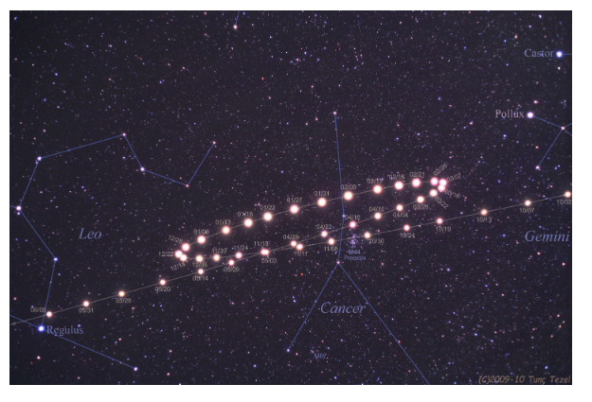

Text 3: EPICYCLES
If you accepted the geocentric view of the Universe, how would you explain the backward and forward motion of Mars and the other planets? Would this motion cause You to change your view of the Universe?

Ptolemy’s explanation in the Almagest was that, as Mars and the other planets moved around the Earth, they also made smaller orbits called “epicycles.” Epicycles were mini-orbits that planets took around imaginary centers as they also orbited the Earth.

The picture below shows the epicycles of Mars, Jupiter, and Saturn as imagined in the geocentric theory of the Universe.

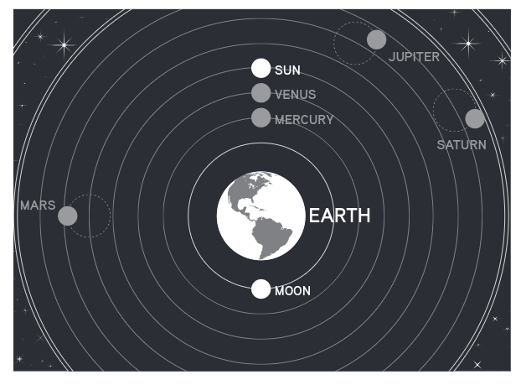

Text 4: Copernicus’s Heliocentric View
In 1543, Copernicus (1473–1543) published a revolutionary book that challenged the geocentric view of the Universe. The texts below explains some of what we know about why Copernicus changed his mind and suggested that the heliocentric view was better than the geocentric view.
Cynthia Stokes Brown, an educator and historian who taught at Dominican University of California at San Rafael, writes:
In 1492, Copernicus went to study at a university. He was 19 years old. At school, he began to question what his teachers were teaching. Even though his professors believed that the Earth was in the center of the Universe and did not move, Copernicus began to question those ideas. His professors also taught about Ptolemy’s views of the Universe, but Copernicus found mathematical errors in Ptolemy’s use of epicycles that did not allow accurate predictions about the movement of the
planets. These predictions would be more accurate, he thought, if the Earth revolved around the Sun instead of the other way around.
After graduating, Copernicus continued his observations of the heavens. To observe the planets, he used devices that looked like wooden yardsticks joined together. He used these to measure the altitude of stars and planets and to calculate the angles between two distant bodies in the sky. He could not use a telescope because no one had invented the telescope yet.
By 1514 Copernicus wrote a short report, called the Little Commentary, that explained his heliocentric theory. In this report, he confidently claimed that the Earth both revolved on its axis and orbited around the Sun. For Copernicus, putting the Sun in the center of the Universe solved many of the problems he found with Ptolemy’s model. He gave this book, however, to only a few of his friends.

Copernicus waited over 20 years before he published his ideas on the heliocentric Universe. He was afraid of creating controversy. Finally, Copernicus agreed to have the Book, On the Revolutions of the Celestial Spheres, published in 1543, the year he died.

Paul Murdin, an astronomer at Cambridge in the United Kingdom and the author of many books on astronomy, writes:
Copernicus put forward the concept that planets revolved around the Sun in outwards order: Mercury, Venus, Earth, Mars, Jupiter and Saturn; while the Moon revolved around the Earth. The book is regarded as the foundation of the heliocentric (Sun-centered) theory of the solar system.... Copernicus showed that the puzzling retrograde motion
of the outer planets, particularly Mars, was a natural consequence of the way that the inner planets revolved around the Sun more quickly than the outer ones — and athlete running quickly on the inside track of a racecourse would see an athlete in front on an outer track moving ahead, but then as he overtook him he would see him apparently
falling behind.

Copernicus’s model asked people to give up thinking that they lived in the center of the Universe. For him, the thought of the Sun illuminating all of the planets as they rotated around it had a sense of great beauty and simplicity

TEXT 05 GALILEO’S LETTER TO KEPLER

Galileo (1564–1642) explains his support for Copernicus in a letter, written in 1597, to Johannes Kepler, a fellow scientist. He wrote the letter 54 years after Copernicus had died.

I accepted the view of Copernicus many years ago. And from this standpoint I have discovered many natural phenomena, which cannot be explained on the basis of the more commonly accepted hypothesis [that the Earth is the center of the Universe]. I have written many direct and indirect arguments for the Copernican view. But until now I have not dared to publish them, alarmed by the fate of Copernicus himself, our master. He has won for himself undying fame in the eyes of a few, but he has been mocked and hooted at by an infinite multitude… I would dare to come forward publicly with my ideas if there were more people of your way of thinking.

Source Modified from The Portable Renaissance Reader, ed. James Bruce Ross and Mary Martin McLaughlin (New York: Viking Press, 1953).

TEXT 06 GALILEO’S TELESCOPE

Galileo invented many things, and though he did not invent the telescope, he did, in 1609, devise a telescope that had more power than previous ones. And he was the first person to use the telescope to study the heavens. With it, he saw that the Moon was not smooth, observed sunspots and a supernova, and discovered the four moons of Jupiter. Did these discoveries support, extend, or challenge the geocentric or the heliocentric view of the Universe?

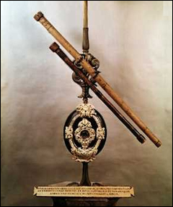

Image credit Telescopes owned by Galileo © Gustavo Tomsich/CORBIS
Text 7: GALILEO DISCOVERS THE MOONS OF JUPITER
In this text, Galileo describes how he discovered the moons of Jupiter. Between January 7 and January 15, 1610, Galileo observed Jupiter and recorded his observations in his journal. At first, Galileo thought the moons were “fixed stars” and did not move, but then he changed his mind. How did he determine that these are moons that revolve around
Jupiter? Do you think this discovery — that Jupiter has moons — supported Copernicus’s view of the Universe? If so, how? If not, why not? Galileo published his discovery in his book The Starry Messenger.
On the seventh day of January of the present year 1610, I inspected the celestial constellations through a spyglass. Jupiter presented himself. I saw that three little stars were positioned near him — small but yet very bright. Although I believed them to be among the number of fixed stars, they nevertheless intrigued me because they appeared to be arranged exactly along a straight line and to be brighter than others of equal size. Two stars were near him on the east and one on the west.
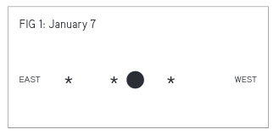

On the eighth day of January, I returned to the same observation, I found a very different arrangement. For all three little stars were to the west of Jupiter and closer to each other than the previous night, as shown in the adjoining sketch. I was aroused by the question of how Jupiter could be to the east of the fixed stars when the day before he had been to the west of two. For this reason I waited eagerly for the next night. But I was disappointed in my hope, for the sky was everywhere covered with clouds.
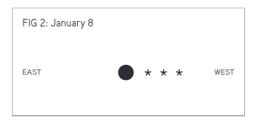
Then, on the tenth day of January, the stars appeared in this position. Only two stars were near him, both to the east. The third, as I thought, was hidden behind Jupiter. I found that change was not in Jupiter, but in the said stars. And therefore I decided that they should be observed more accurately and diligently.
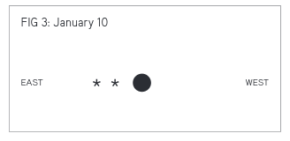
I therefore arrived at the conclusion, entirely beyond doubt, that in the heavens there are three stars wandering around Jupiter, like Venus and Mercury around the Sun. Also that there are not only three, but four wandering stars. On the thirteenth day of January, three were on the west and one on the east.
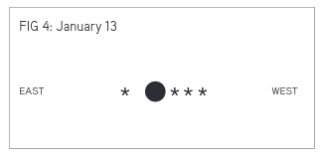

On the fourteenth day of January, the weather was cloudy. On the fifteenth day of January, the four stars were positioned with respect to Jupiter as shown in the next figure.
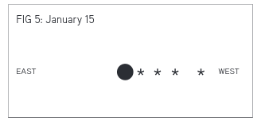
Our vision offers us four stars wandering around Jupiter like the Moon around the Earth while all together with Jupiter traverse a great circle around the Sun in the space of 12 years.

TEXT 08
THE HELIOCENTRIC VIEW
GROWS IN POPULARITY
Before Copernicus and Galileo, most people and most powerful organizations, such as the Roman Catholic Church in Europe, thought the geocentric view was correct. Therefore, both Copernicus and Galileo were afraid to publish their new ideas and with good reason. Copernicus waited until near his death to allow his book to be published and the Roman Catholic Church eventually tried and found Galileo guilty of holding
heliocentric views that went against the Bible. As you think about why and when people should change their minds, is it important to think about social pressure? Is it easier to change your mind when others are
doing so? Take a look at this timeline below. We have included some key dates in the change in collective learning from the geocentric to heliocentric views. How does this brief timeline support, extend, or challenge your ideas about when and why people should change their minds?

1633 Roman Catholic Church Outlaws Heliocentric View
The Roman Catholic Church bans the teaching of heliocentric theories: “The
proposition that the Sun is the center of the world and does not move from
its place is absurd and false.... The proposition that the Earth is not the center
of the world and...that it moves...is equally absurd and false...and at least an
error in faith.”

1661 Newton Studies Heliocentric View in College
Among the books that Isaac Newton reads at Trinity College, Cambridge is
Galileo’s Dialogue, which challenges the geocentric idea.

1686 Popular Book Promotes Heliocentric View
Bernard de Fontenelle, a French thinker, publishes Conversations on the Plurality
of Worlds. In it he accepts the heliocentric view. The book becomes very popular
and is published in many languages.

1687 Newton Publishes a Scholarly Book Improving on Heliocentric View
Newton publishes his Principia Mathematica, offering more proof and many
corrections for Copernicus and Galileo’s heliocentric view.

1758 Roman Catholic Church Drops Its Heliocentric Ban
The Catholic Church drops the prohibition of books advocating heliocentric theory.

1774 Roman Catholic Church Opens its First Observatory

1891 Roman Catholic Church Opens the Vatican Observatory

1992 Roman Catholic Church Expresses Regret for Treatment of Galileo

2008 Catholic News Reports on Roman Catholic Church Plans to Honor Galileo with a Statue in the Vatican Gardens These plans, however, are later put on hold.

 | Exceeding  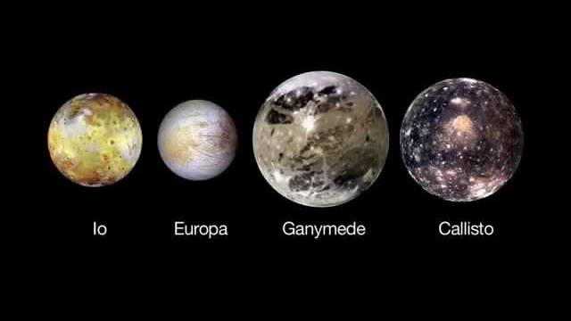 | Meeting | Approaching | Beginning
Claim: I can hypothesize an answer to a question | My claim is precise and significantly answers how and why individuals change their mind. | My claim is clear and answers how and why individuals change their mind. | My claim answers how or why individuals change their mind but not both. | My claim is vague or simple and lacks connection to a source.
IDENTIFY, Analyze, and Understand the essential parts of primary and secondary sources. | I can IDENTIFY :  1. Who wrote it  2. When it was written  3. Where it was written  4. Why it was written (Analyze the author's purpose)  5. The author's point of view  6. Reliability AND Credibility | I can IDENTIFY:  1. Who wrote it  2. When it was written  3. Where it was written  4. Why it was written (Analyze the author's purpose)  5. The author's point of view  6. Reliability OR Credibility | I can IDENTIFY:  1. Who wrote it  2. When it was written  3. Where it was written  4. Why it was written (Analyze the author's purpose)  AND try to IDENTIFY  5. Author's point of view  6. Reliability OR Credibility | I can IDENTIFY:  1. Who wrote it  2. When it was written  3. Where it was written  AND try to IDENTIFY  4. Author's purpose  5. Author's point of view
Reasoning: SUPPORT my claim with: | I SUPPORT my claim with:  - An explanation that is thorough, convincing and connected to the time period studied.  - Primary/secondary sources connected to time period studied.  - Acknowledgment of counterclaims and an explanation of why mine is better. | I SUPPORT my claim with:  - An explanation that is thorough, convincing and connected to the time period studied.  - With multiple primary/secondary sources connected to time period studied. | I SUPPORT my claim with:  - An explanation that is connected to time period studied but may not be thorough or convincing.  - A primary/secondary source(s) connected to time period studied. | I SUPPORT my claim with:  - An explanation that is too brief or not connected to time period studied.

