Lesson 6.1 Ways of Knowing-Early Humans Video Questions Answer Key
As you watch the each of the videos, answer the following questions:
What is Anthropology and How Has It Helped Us to Understand the Past?
Questions | Notes
What is anthropology and how has it helped us to understand the past?  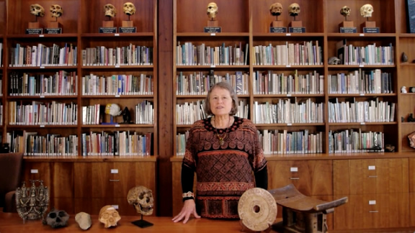 | - 0:28 What is anthropology?  Sample answer: The holistic study of humankind; the study of how, when, and why humans and different cultures develop and live.  - 3:00 How does anthropology inform us about early humans?  Sample answer: Anthropologists find missing links to the human story by studying different cultures; by studying the physical traits of humans; by studying languages; and by studying prehistory through archaeology and fossils.
Summary (What is the BIG idea presented in the video):

Being an anthropologist is like being a detective who uses clues from both the modern world and the past to learn about our early human ancestors. If you like traveling, seeing new cultures, learning a new language, or searching for clues to solve puzzles, you’ll make a great anthropologist!

What is Archaeology and How Has It Helped Us to Understand the Past?
Questions | Notes
What is archaeology and how has it helped us to understand the past?  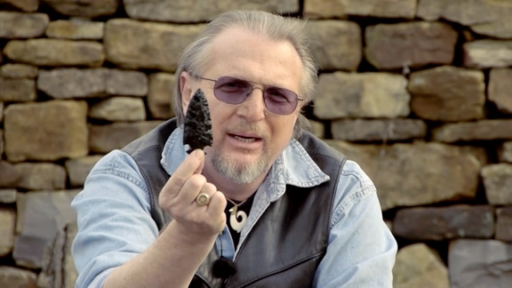 | - 0:25 What is archaeology?  Sample answer: The study of ancient people and the world that they lived in.  - 0:35 What do archaeologists do?  Sample answer: Dig for fossils, look for new sites, explore and survey, analyze findings.  - 3:25 How does archaeology teach us about early humans? What are the different types of archaeology?  Sample answer: Archaeologists interact with other disciplines. Historical archaeology examines written records of the past; prehistoric archaeology examines fossils from before the written record; experimental archaeology simulates how ancient people lived.
Summary (What is the BIG idea presented in the video):

Archaeology informs us about early humans by examining the remains of ancient peoples (fossils) and the items they left behind, such as tools and pottery.

What Makes Humans Different?
Questions | Notes
What makes humans different from other species? | - How have humans impacted the world?  Sample answer: They have built towns and cities, roads and superhighways, changed forests into farmland.  2. What things have made humans different from other species?  Sample answer: They started entering new environments, building houses, wearing clothing, and using new types of tools.  3. What is so important about human language?  Sample answer: It allows for collective learning.
Summary (What is the BIG idea presented in the video):

While we share many commonalities with other species on our planet, it is our language that sets us apart and has made us so powerful. Our human language allows us to communicate great amounts of information with precision, and it can be stored in the collective memory, allowing it to be passed on from one generation to the next (Collective Learning).

