Lesson 6.1 Ways of Knowing-Early Humans Video Questions
As you watch the each of the videos, answer the following questions:
What is Anthropology and How Has It Helped Us to Understand the Past?
Questions | Notes
What is anthropology and how has it helped us to understand the past?  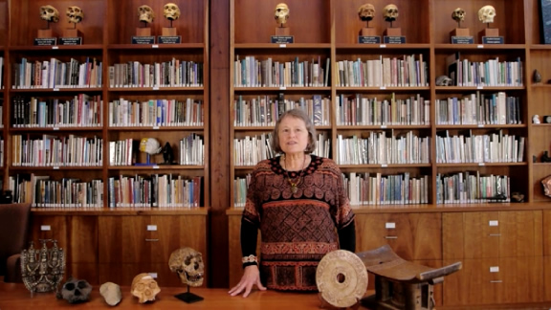 | - 0:28 What is anthropology?  - 3:00 How does anthropology inform us about early humans?
Summary (What is the BIG idea presented in the video):

What is Archaeology and How Has It Helped Us to Understand the Past?
Questions | Notes
What is archaeology and how has it helped us to understand the past?  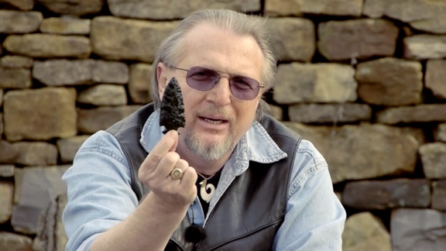 | - 0:25 What is archaeology?  - 0:35 What do archaeologists do?  - 3:25 How does archaeology teach us about early humans? What are the different types of archaeology?
Summary (What is the BIG idea presented in the video):

What Makes Humans Different?
Questions | Notes
What makes humans different from other species? | - How have humans impacted the world?  2. What things have made humans different from other species?  3. What is so important about human language?
Summary (What is the BIG idea presented in the video):

How Did Our Ancestors Evolve?
Questions | Notes
What makes humans different from other species?  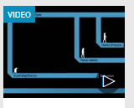 | - What is LUCA? (0:30)  2. How do we know about our early ancestors? (1:37)  3. What is evolution radiation? (4:00)  - What are some important characteristics of our tree dwelling ancestors? (4:30)  - What percentage DNA do we share with chimps? (5:50)  - Why did our ancestors possibly become bipedal? (6:20)  .  - Who are some of our early ancestors? (7:30)
Summary (What is the BIG idea presented in the video):

