A Big History of Everything: Life
As you watch the each of the videos, answer the following questions:
A Big History of Everything: Life
Questions | Notes
How did life emerge on Earth? | - 0:58 What do most people believe is the reason for the emergence of life on Earth?  - 1:51 What is the biological blueprint for everything that exists?  - 2:05 What is the earliest form of life?  - 5:32 Why is the egg a critical development?  - 7:49 What did the extinction of the dinosaurs clear the way for?  - 9:32 What did humans ultimately evolve from?  - 11:55 How did primates take the first step toward being human?
Summary (What is the BIG idea presented in the video):

What Did Stars Give Us?
Questions | Notes
What elements are produced in aging and dying stars?  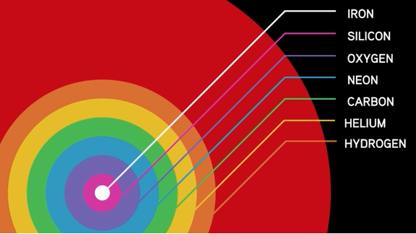 | - Where did all the other elements come from?  - What did the cooling of the universe allow?  - How hot is the surface of the sun?  - What temperature do you need to get Carbon? To get Iron?  - What happens as stars begin to run out of fuel?  - What is a supernova, and what does it do?  - What might the star of Bethlehem have been?  - Compare the percentage of Hydrogen and Helium to all other elements.
Summary (What is the BIG idea presented in the video):

