Mankind: Speed Video Questions
Questions | Notes
What types of changes took place during the Modern Revolution?  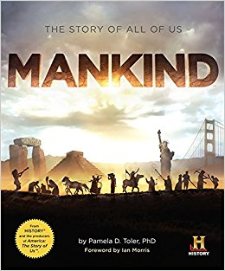 | American Civil War 00:00 – 6:34  1. As the Union troops approached Richmond, what did the Confederates decide to do? How did this decision backfire?  Mass Production & Japanese Modernization 6:34 – 13:59  2. Japan had been isolated for nearly 200 years in an attempt to preserve their unique culture. During this time, what class of people moved to almost mystical status in Japanese culture?  3. Iwasaki Yataro was from an old samurai family. What did he do to bring Japan into the modern world?  4. How quickly did Japan industrialize?  Emigration & the RMS Titanic 14:00 – 24:28  5. What technology enabled RMS Titanic officer Jack Phillips to communicate with land?  6. In this period, 1 in 20 people on the planet emigrated. The most popular destination was America. Why did so many people come?  7. The third‐class cabins flooded first. What problem did the third‐class passengers encounter as they attempted to flee the vessel?  8. Did Theodor de Mulder live or die? How?  9. According to James Meigs, how did the sinking of Titanic affect how people viewed technology?  The Quest for Rubber 24:28 – 27:49  10. What did Charles Goodyear sacrifice in his quest to make rubber useful? (Name at least three).  Exploitation in the Congo 27:49 – 34:33  11. What did Harris decide to do about the problem?  12. Writer Judith Lindbergh said that, “Just one look at what had happened to these people in the Congo...was able to communicate so broadly and so horrifically that it transformed world opinion and it changed society.” What about these photos enabled them to change society?  Alexander Fleming & the Discovery of Antibiotics 34:33 ‐ 44:12  13. Life expectancy on the front line was approximately six weeks. 1/3 of these deaths did not come from weapons, but from...  14. Before this time, doctors treated wounds with carbolic acid. This killed the bacteria. What else did it kill – making it a problem for battlefield medicine?  15. What solution did Alexander Fleming find to the problem described in the previous question
Summary (What is the BIG idea presented in the video):

