Mass Extinction Mini-Lesson
As we have seen throughout Unit 5, life on Earth has taken many forms over the past 3 billion years. In this mini-lesson, we will examine the 5 mass extinctions that have taken place on Earth, identify which life forms died off and which ones survived and thrived, and speculate whether humans may be responsible for a possible 6th mass extinction.
Part 1
Use the following website to find:
- The name (age) of each mass extinction.
- The approximate date of each mass extinction.
- The percentage of life forms that went extinct.
- The possible cause for the mass extinction.
https://cosmosmagazine.com/palaeontology/big-five-extinctions
Name (Age) | Approximate Date | Percentage of Life that went Extinct | Cause

Use the following website (scroll down to the 5 Mass Extinctions) and find at least 1 species that went extinct during each mass extinction:
http://qrius.si.edu/explore-science/jump/extinction-over-time
Name (Age) | Species
Part 2
How do we know about these mass extinctions? We will watch this video to learn about the evidence gathered by a team of geologists who proved an asteroid was responsible for wiping out the dinosaurs, and our guide will be one of the lead geologists who made this discovery, Walter Alvarez! If the asteroid had been less than an hour earlier or later, humans might never have existed.
How We Proved an Asteroid Wiped Out the Dinosaurs
Questions | Notes
If there were no humans around to witness the extinction of the dinosaurs, then how do we know that an asteroid was responsible for their demise?  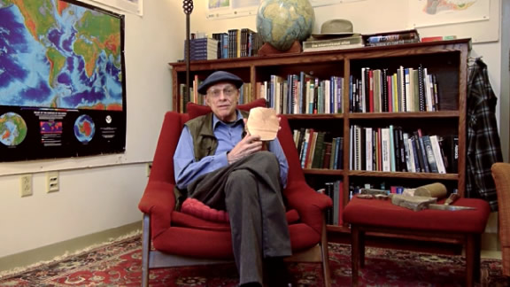 | 1.) 2:55 When Alvarez explored the clay between the Cretaceous and Tertiary rocks, what clue did the clay provide, and why were members of his team surprised by what they found?  2.) 4:03 What did Alvarez think about the energy of the asteroid impact and the effect it might have had on the biosphere?  3.) 4:24 Why was the claim that the dinosaurs became extinct because of an asteroid impact initially met with skepticism by some?  4.) 4:38 What was the second set of clues discovered by scientists to support the claim that an asteroid impact destroyed the dinosaurs?  5.) 6:29 What was the third clue found to support the claim that an asteroid impact destroyed the dinosaurs?  6.) 7:15 How is the development of the story of the asteroid impact that killed the dinosaurs an example of the scientific method at work?
Summary (What is the BIG idea presented in the video):

Part 3
Are we witnessing (or even taking part in) the 6th mass extinction? Let’s take a look at the following video clip and jot down some ways that humans are responsible for causing the extinction of various species around the world:
https://www.youtube.com/watch?v=z9gHuAwxwAs
1.)
2.)
3.)
4.)
5.)

What Extinct Species Are Humans Responsible for? According to some experts, humans are directly responsible for the extinct of at least 322 different species in the last 500 years alone. Below is a link to a few of these species, as well as a list of species that are on the endangered list:
https://www.huffingtonpost.com/2013/10/22/11-extinct-animals_n_4078988.html
Name two species that humans have caused to go extinct:
1.)
2.)
https://www.worldwildlife.org/species/directory?direction=desc&sort=extinction_status
Name at least 5 species that are either critically endangered or endangered:
1.)
2.)
3.)
4.)
5.)

Things to remember about the survival of a species
Species have a better chance for survival if:
- They are not highly specialized and can adapt to live in a variety of locations.
- They are not confined to one small location such as an island or a lake.
- They frequently reproduce.
- They have a natural means of defense and/or protection.
- They are not overly large or at the top of the food chain.

