Mini-Thresholds of Life Video Questions
As you watch the each of the videos, answer the following questions:
How Did Life Begin and Change Video Questions
Questions | Notes
What are the various mini-thresholds of life on Earth?  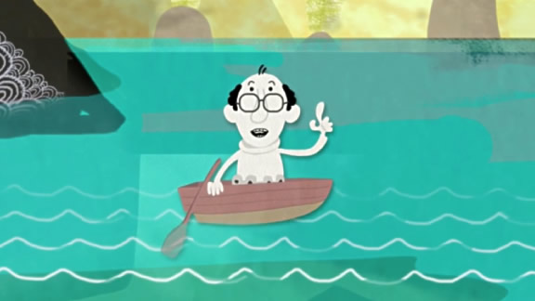 | - 1:12 What makes the emergence of photosynthesizing cells a mini-threshold?  - 1:58 What makes the emergence of eukaryotes a mini-threshold?  - 3:00 What makes the emergence of multicelled organisms a mini-threshold?  - 3:37 What makes the emergence of brains a mini-threshold?  - 4:13 What makes the move of sea creatures to land a mini-threshold?  - 5:03 What makes the emergence of mammals a mini-threshold?
Summary (What is the BIG idea presented in the video):

