**Reading/Thinking/Writing Like an Anthropologist**



**So, what do anthropologists use to unlock clues to the past?**

* **Fossils:** The remains of something that was once alive.
* **Artifacts: Anything made or used by humans.**

**Key Terms**

**Primary Source: Any source of information created at the time of an event.**

**Secondary Source: Any source of information created after the time of an event.**

**Anthropology: The scientific study of humans.**

**Archaeology: The recovery and study of the remains of the past.**

**Anatomical Structures of the Skull**

**Foramen Magnum: Hole in the base of the skull where the spinal cord attaches to the brain.**

**Canine Incisors: Pointy, fang-like teeth found in most mammals.**

**Cranial Capacity: The interior space of the skull where the brain is found.**

**Brow Ridge: Bumpy ridge that runs along the forehead, above the eyes.**

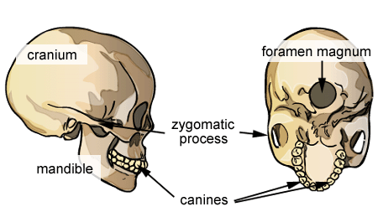

Rank the skulls in order of age from Oldest to Youngest, and then explain why you ranked them that way.

_____ _____ _____ _____ _____ _____

WHY?

**Skull #6**

Foramen Magnum: (Where is it Located?)

Canine Incisors: (Are they present?)

Cranial Capacity: (How big compared to others?)

Brow Ridge: (Is it prominent?)

**Skull #5**

Foramen Magnum: (Where is it Located?)

Canine Incisors: (Are they present?)

Cranial Capacity: (How big compared to others?)

Brow Ridge: (Is it prominent?)

**Skull #1**

Foramen Magnum: (Where is it Located?)

Canine Incisors: (Are they present?)

Cranial Capacity: (How big compared to others?)

Brow Ridge: (Is it prominent?)

**Skull #3**

Foramen Magnum: (Where is it Located?)

Canine Incisors: (Are they present?)

Cranial Capacity: (How big compared to others?)

Brow Ridge: (Is it prominent?)

**Skull #4**

Foramen Magnum: (Where is it Located?)

Canine Incisors: (Are they present?)

Cranial Capacity: (How big compared to others?)

Brow Ridge: (Is it prominent?)

**Skull #2**

Foramen Magnum: (Where is it Located?)

Canine Incisors: (Are they present?)

Cranial Capacity: (How big compared to others?)

Brow Ridge: (Is it prominent?)