Scale Drawing Project

Over the course of the past couple of class periods we have talked about looking at things from different scales. Sometimes we need to zoom in to see the fine details, and sometimes we need to zoom out to see the big picture. For this project, you are going to pick an object, any object, and then depict that object in three different drawings that show it from three different scales. Along with each drawing, you will also provide a brief caption that explains why the scale is specifically important for showing the various details of the object. Be sure that your drawings are colorful and neatly done, and represents your best work This project will be due on Wednesday, October 10, 2018. To give you an idea of what this project might look like, here is an example:
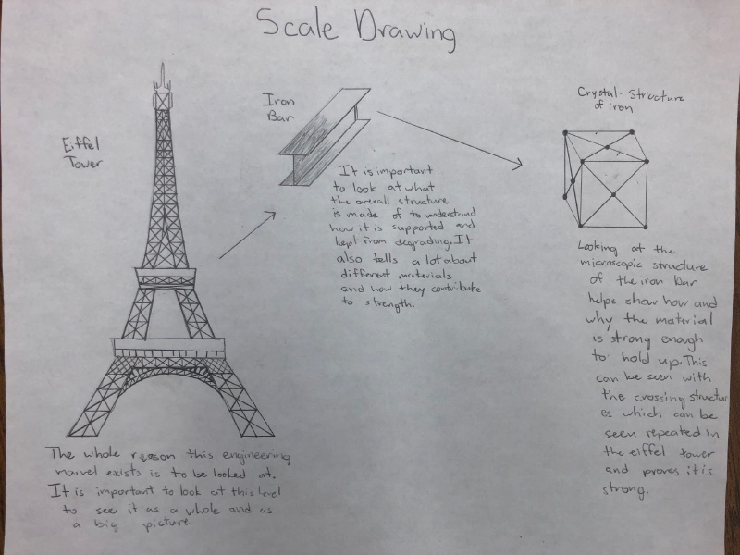
 | Exceeding | Meeting | Approaching | Beginning
SUPPORT my claim with: | I SUPPORT my claim with:  - I have 3 drawings and an explanation for the scale of my drawings that is precise, thorough, and convincing. | I SUPPORT my claim with:  - I have 3 drawings and an explanation for the scale of my drawings that is thorough and convincing. | I SUPPORT my claim with:  - I have 3 drawings and an explanation for my scale of my drawings, but the explanations may not be thorough or convincing. | I SUPPORT my claim with:  - I have less than 3 drawings and am lacking an explanation for the scale of my drawings.

