Name________________________________
Date___________________________
Period__________________

Almost half of the people of Western Europe died in a great sickness known as the Bubonic Plague. The plague was also referred to as "the Black Death” because the skin of diseased people turned a dark gray color. It apparently began in China’s Gobi Desert, and it killed about 35 million Asian people. When sailors traveled to Asia, rats returned with them to Europe. Fleas living on the blood of infected rats then transferred the disease to the European people.
In 1347, Italian merchant ships returned from the Black Sea, one of the links along the trade route between Europe and China. Many of the sailors were already dying of the plague, and within days the disease had spread from the port cities to the surrounding countryside. The disease spread as far as England within a year.
The Europeans were susceptible to disease because they lived in crowded surroundings with very poor sanitary conditions. The Europeans often ate stale or diseased meat because refrigeration had not yet been invented. Also, medicine was primitive and unable to remedy an illness that modern technology might have cured. Bad medical advice also advanced the plague. People were often advised to not bathe because open skin pores might let in the disease.
Death from the plague was horrible, but swift. The Italian writer Boccaccio said victims often “ate lunch with their friends, and ate dinner with their ancestors in paradise.” The first signs were generally aching limbs, and vomiting of blood. Then the lymph nodes would begin to swell. The lymph nodes are glands found in the neck, armpits, and groin. The swelling continued for three or four days until the lymph nodes burst. The swiftness of the disease, the enormous pain, the grotesque appearance of the victims, all served to make the plague especially horrifying.
Some Europeans believed the plague was a sign from God. Groups known as flagellants tried to atone for the sins of the world by inflicting punishments upon themselves. They also had a tendency to persecute Jews and even clergymen who spoke out against them. Pope Clement VI condemned the flagellants, but they continued to reappear in times of plague.
The Bubonic Plague continued to affect cities from time to time for hundreds of years. It still exists and is common among rodents. We have a cure for the disease, but occasionally people in isolated places still die from the Bubonic Plague.
Impacts of the Black Death
- The Black Death killed so many people that they were buried without priests or ceremonies (causes a loss in religious faith).
- In some villages nearly everyone died or fled. 75 – 200 million people were killed.
- The manor system fell apart because there were not enough people to work the fields.
- Serfs were able to become free labors and their quality of life increased.
- People abandoned the manors and villages and moved to the cities.
MSNBC.com
L.A. woman diagnosed with bubonic plague
Patient in stable condition with rare, modern case of 'Black Death'
The Associated Press
updated 2:18 p.m. CT, Wed., April. 19, 2006
LOS ANGELES - A woman is in stable condition with bubonic plague, the first confirmed human case in Los Angeles County since 1984, health officials said Tuesday.
The woman, who was not identified, was admitted to a hospital April 13 with a fever, swollen lymph nodes and other symptoms. A blood test confirmed the bacterial disease, and she was given antibiotics, officials said.
Bubonic plague is not contagious, but if left untreated it can morph into pneumonic plague, which is. Bubonic plague is usually transmitted to humans from the bites of fleas infected by rodents.
Health officials said they suspect the woman was exposed by fleas in her home and that there was no cause for alarm. An estimated 10 to 20 Americans contract plague each year, mostly in rural communities.
Bubonic plague is believed to have been the "Black Death" that killed 25 million people in Europe between 1346 and 1351.
Copyright 2006 The Associated Press. All rights reserved. This material may not be published, broadcast, rewritten or redistributed.
URL: http://www.msnbc.msn.com/id/12387983/

The Black Death Study Questions

- How many people were killed in Western Europe by the Black Death?

- Why was the bubonic plague called the Black Death?

- Where did the black plague begin, and how many people did it kill?

- How did the Black Death get from Asia to Europe?

- When did the Black Death first arrive in Europe?

- Why were Europeans susceptible to this disease?

- What were some of the symptoms of the Black Death?

- Who were the “flagellants” and what did they do?

- What were some of the impacts of the Black Death on Europe?

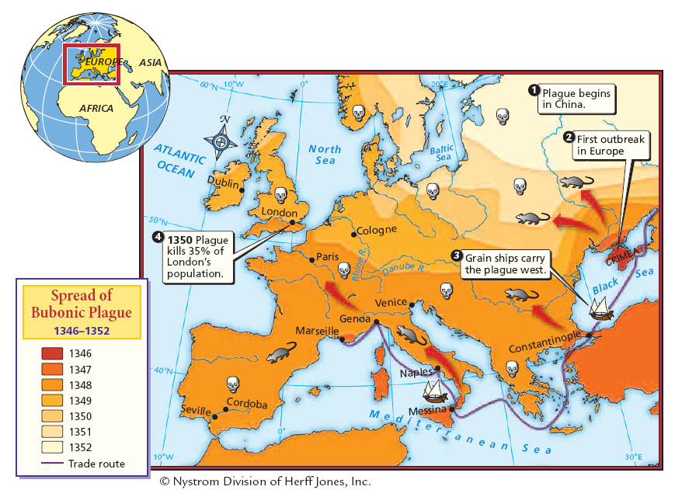

“The Black Death Strikes Sicily” by Michael Platiensis
Vocabulary
Galleys: long, low trading ships.
Virulent: extremely poisonous.
Evade: escape
Undermined: weakened
Emanated: came forth.
Dispersed: scattered
Attained: achieved
Pestilence: fatal epidemic.

About the Reading: The Black Death struck Europe with astonishing speed and deadliness in the 1340s. Michael Platiensis’ 1357 account brings to life the terror and desperation of townspeople on the coast of Sicily infected by arriving sailors.

At the beginning of October, in … 1347, twelve Genoese galleys entered the harbor of Messina. In their bones they bore so virulent a disease that anyone who only spoke to them was seized by a mortal illness and in no manner could evade death. The infection spread to everyone who had any contact with the diseased. Those infected felt themselves penetrated by a pain throughout their whole bodies and, so to say, undermined. Then there developed on the thighs and upper arms a boil about the size of a lentil which the people called “burn boil”. This infected the whole body, and penetrated it so that the patient violently vomited blood. This vomiting of blood continued without intermission for three days, there being no means of healing it, and then the patient expired.

Not only all those who had speech with them died, but also those who had touched or used any of their things. When the inhabitants of Messina discovered that this sudden death emanated from the Genoese ships they hurriedly ordered them out of the harbor and town. But the evil remained and caused a fearful outbreak of death. Soon men hated each other so much that if a son was attacked by the disease his father would not tend to him. If, in spite of all, he dared to approach him, he was immediately infected and was bound to die within three days. Nor was this all; all those dwelling in the same house with him, even the cats and other domestic animals, followed him in death. As the number of death increased in Messina many desired to confess their sins to the priests and to draw up their last will and testament. But lawyers and notaries refused to enter the houses of the diseased.
Soon the corpses were lying forsaken in the houses. No son, no father, and no relation dared to enter, but they hired servants with high wages to bury the dead. The houses of the deceased remained open with all their valuables, gold and jewels. When the catastrophe had reached its climax the Messinians resolved to emigrate. One portion of them settled in the vineyards and fields, but a larger portion sought refuge in the town of Catania. The disease clung to the fugitives and accompanied them everywhere they turned in search of help. Many of the fleeing fell down by the roadside and dragged themselves into the fields and bushes to expire. Those who reached Catania breathed their last in the hospitals there. The terrified citizens would not permit the burying of fugitives from Messina within the town, and so they were all thrown into deep trenches outside the city walls.
Thus the people of Messina dispersed over the whole island of Sicily and with them the disease, so that innumerable people died. The town of Catania lost all its inhabitants, and ultimately sank into complete oblivion. When the plague had attained its height in Catania, the patriarch endowed all male citizens, even the youngest, with all priestly powers for the absolution of sin which he himself possessed as bishop and patriarch. But the pestilence raged from October 1347 to April 1348. The patriarch himself was one of the last to be carried off. He died fulfilling his duty.

- What happened to bodies of people who died?
- How did the disease spread from Messina to the rest of Sicily?
- What do you think was the worst effect of the plague on the people of Sicily?

