The Early Atmosphere Video Questions
Questions
What was the atmosphere of early Earth like?  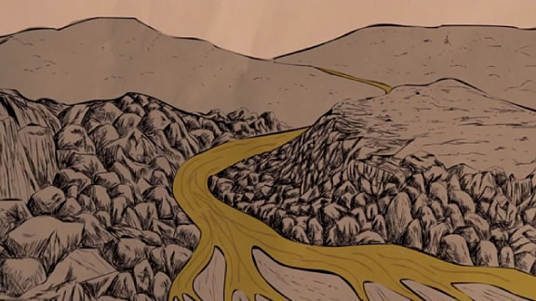 | - 0:37 How did the first atmosphere of the Earth form?  - 0:48 What is the “greenhouse effect,” and how did the conditions on the early Earth allow for its development?  - 1:41 How did the formation of the Moon impact the Earth?  - 2:11 How did the Earth’s atmosphere change during the Hadean eon?  - 3:07 How did the Earth’s atmosphere change during the Archaean eon?  - 3:55 What was the Great Oxidation Event and why did it happen?  - 4:50 How did the buildup of oxygen in the atmosphere impact that Earth’s climate?
Summary (What is the BIG idea presented in the video):

