The Universe -Life and Death of a Star
As you watch the each of the videos, answer the following questions:
The Universe - Life and Death of a Star
Questions | Notes
What information have scientists been able to learn about the life cycle of a star?  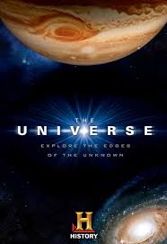 | - 2:30 What are the pillars made of in the “Pillars of Creation”?  - 3:20 What is the most important force in astronomy?  - 4:30 What is the early phase of the star called once the gas and dust begin to coalesce?  - 7:25 At what stage in star development does a star spend most of its life?  - 7:50 What characteristic indicates how hot a star is?  - 8:15 Small, cool red stars are called ____ ________.  - 9:05 Large, blue stars are how much larger than the Sun?  - 9:25 Which star lives the longest, the star with the higher mass or the star with the lower mass?  - 11:50 What will happen to our star once all of its fuel has been burned?  - 17:45 What is the phase of a star called where it simply cools and fades away?  - 23:20 Why do most stars not necessarily die in the time we would normally expect them to?  - 24:30 What is the result of the collapse of the iron core?  - 26:15 Where did all the elements in our bodies come from?  - 28:00 About how big (or small) are neutron stars?  - 36:45 What would happen to our sun if a dense white dwarf collided with it?  - 38:35 To what does the show compare a globular cluster?  - 39:50 What do they call the blue stars found in old globular clusters?  - 40:25 Where does Joshua Barnes think they come from?  - 41:40 At what stage of a star’s life are black holes, white dwarfs, etc.?  - 42:00 What is a brown dwarf?
Summary (What is the BIG idea presented in the video):

