Threshold 6 Video Questions
As you watch the each of the videos, answer the following questions:
What were the Ingredients & Goldilocks Conditions for Threshold 6?
Questions | Notes
What were the ingredients and goldilocks conditions for Thresholds 6?  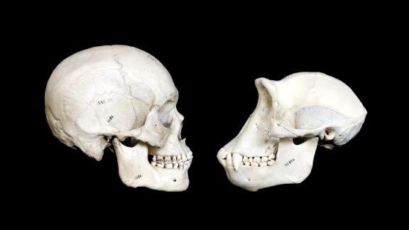 | - 1:00 What event allowed mammals to evolve and flourish on Earth?  - 1:16 When did our species (Homo sapiens) evolve?  - 2:14 What are the ingredients and Goldilocks Conditions necessary for the new complexity of collective learning?
Summary (What is the BIG idea presented in the video):

