To Scale: The Solar System
Questions | Notes
What would our solar system look like if we shrunk it down to a scale model?  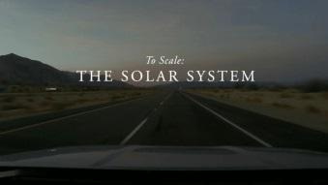 | - 0:59 Why aren’t pictures of the Solar System to scale?  - 1:53 How much space do you need to build a scale model of the Solar System if the Earth is only the size of a marble?  - 4:15 What planet orbits at the edge of the Solar System?  - 5:22 How do you know that they’ve made their model correctly, with the right proportions?
Summary (What is the BIG idea presented in the video):

