Unit #6 Vocabulary Trading Cards Mini-Project

For this mini-project, you will be creating a series of trading cards for each of the vocabulary terms for Unit #6: Early Humans. Each trading card should have all of the following features:

- The vocabulary term at the top of each card in bright, bold color.
- A picture (in color) that represents the vocabulary term directly under the term.
- The definition of the vocabulary term on the back of each card.

This project will be due on __________________________.

Example Trading Card

Australopithecine  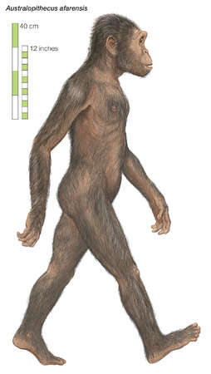 | Australopithecine  An early group of hominine species with brains about the size of those of chimpanzees; they flourished in Africa between 4 and 1 million years ago.

- Anthropology

- archaeology

- Australopithecine

- bipedalism

- collective learning

- culture

- foraging

- Fossil

- Genetics

- hominines

- Homo ergaster or Homo erectus

- Homo habilis

- Homo sapiens

- migration

- Neanderthal

- Nomadic

- Paleolithic era

- paleontology

- Primate

- symbolic language

