Name_____________________________
Date____________________
Period_________
Unit #2 Vocabulary Flipbook Project
Read over the following vocabulary terms, and then put a check in the column that best describes your understanding of the term.
 | I know what this is | I have heard it but am not sure of the meaning | This is new to me
Astronomy
Atom
Authority
Claim Testing
Collective Learning
Cosmic Background Radiation (CBR)
Evidence
Gravity
Hydrogen
Intuition
Light-Year
Logic
Nucleus (atomic)
Proton
Telescope

Now that you have completed and correctly defined all of the vocabulary terms for Unit #2, you are going to create a “Unit #2 Vocabulary Flipbook”. For this mini-project, you will complete all of the following:
1.) On the front cover write the title, “Unit #2 Vocabulary Flipbook” by: Your Name.
2.) On each of the pages, you will have:
a.) The Term
b.) The Definition
c.) A picture that goes along with the term.
3.) Be sure to have plenty of bright, bold color in each of your pictures.
Example:
Telescope
An instrument used for viewing distant objects, including planets, stars, and galaxies.
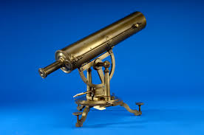

This mini project will be due on __________________________________ and worth 325 points.
Unit #2 Vocabulary Flipbook Rubric
_____/250 The flipbook contains each of the 15 terms with the correct definition and a picture.
_____/25 The flipbook has the title, “Unit #2 Vocabulary Flipbook” by: Your Name.
_____/50 The flipbook has plenty of bright, bold color.

_____/325 Total Points _____ % _____ Letter Grade

